Research Report on Catholic Schools

by

Richard Gambitta, Ph.D.

Richard Jones, Ph.D.

Gabriel Acevedo, Ph.D.

February, 2006

Commissioned by the Archdiocese of San Antonio

&

Research Conducted by the

UTSA Institute for Law and Public Affairs
&
UTSA Culture and Policy Institute

Introduction
Professors, research associates, and staff at the University of Texas at San Antonio (UTSA), affiliated with the UTSA’s Institute for Law and Public Affairs and the Culture and Policy Institute, conducted the research for the Private and Public Schools Study 2005 (hereafter in this report referred to as the Project). The study examined multiple aspects of parental decision-making associated with the selection of schools for their children and their perceptions, preferences, and attitudes associated with Catholic, public, and private (non-Catholic) schools. The research project included a major telephone survey, focusing on Catholic households with school-age children, but including a smattering of non-Catholic households that had children attending Catholic schools. A detailed description of the sample(s) appears in Part III of this report (see page 32) where we discuss the survey findings. In brief, researchers conducted the survey in English or Spanish, depending on the respondent’s preferred language, with 819 respondents activated and 667 respondents completing the entire survey. Researchers drew respondents from two sources: (a) a systematic sample of households with children attending Catholic schools across Bexar County, drawn from Catholic school directories (over four-hundred interviews completed) and (b) a random sample of Bexar County households with school-aged children where the respondent was Catholic (over two-hundred interviews completed.) The first group sent their children to Catholic schools, the latter mostly to public schools, therein allowing the research team to examine school choice attendance from the perspective of those Catholic parents who do and those who do not send their children to Catholic schools. Overall, the sample included 492 households with at least one child attending a Catholic school, 248 with at least one child attending a public school, and 42 attending at a private school. Moreover, the Project examined enrollment data of Bexar County Catholic schools across time, reviewed demographic information on Bexar County as related to past or potential school enrollments, reviewed the literature on Catholic and private schools, and reviewed what other cities and diocese were doing related to Catholic schools. The lead team members conducted a series of diverse, detailed personal interviews with over twenty Catholic clergy, Archdiocese personnel, and Catholic school administrators, board members, parents, and alumni in preparation for the construction of the survey instrument and to explore various intricacies and subtleties associated with the values, purposes, and operations of Catholic school education. Furthermore, the research team has made five formal presentations to groups concerning the preliminary findings of the Project, interacting with participants to further enrich the material and inquiry. At various points, the researchers have unified, separated, and synthesized data from the diverse components of the research project to enhance the analyses to illuminate answers to research questions. All of this research culminates in the findings summarized in the following report.

The primary research investigators included UTSA professors Richard Gambitta (Ph.D., political science.), Richard Jones (Ph.D., geography), and Gabriel Acevedo (Ph.D., sociology). Other PhDs. engaged in some respect in the research effort included Raymond Garza, Betty Merchant, Thankam Sunil, S. Lewis Coleman, and Arturo Vega, adding expertise and insights from the disciplines of psychology, education, sociology, economics, and public administration, respectively. Assisting with diverse components of the Project were Anthony Arriaga (J.D.), William Chance (M.A.), Martha Treviño Crawford (MA), Nydia Guerrero (MPA), Maria Maya Jones (MA), Cecilia Sandoval (M.A.), and Jason Sewell (B.A.). Over twenty others conducted the extensive survey interviews, assisted with the administration of the sample, prepared the questionnaire in English and Spanish, and entered the data into UTSA computers. The Archdiocese of San Antonio funded a major part of this Project in conjunction with the two Institutes of the UTSA.

This report constitutes a work-in-progress, presenting findings, information, and analyses from the research project to the Archdiocese of San Antonio. The primary investigators believe that this Project has produced rich data, will provide ongoing information and insights of significant value, and produce themes appropriate to decision-making concerning the issues associated with Catholic schools and planning.

Part I: Summary Conclusions and Recommendations
The research team suggests that the Archdiocese’s Task Forces consider especially the five conclusions and recommendations in designing strategic initiatives. The primary researchers intend this opening component to summarize and cluster some of the Project’s findings and facilitate recommendations to meet the challenges to Catholic education in this Archdiocese.

Much news has focused on the closing of Catholic schools in traditional neighborhoods locally and in declining inner-city districts nationally, but little news attention has highlighted the significant successes of establishing new Catholic schools in areas where the population is increasing (if not exploding). One example from numerous recent successes of a parish school is Our Lady of Atonement Academy, outside of N Loop 1604 W, which established a pre-K through 8 school and is now phasing in a high school.

Important to note at the outset, the perception of the Catholic population in Bexar County is that Catholic schools provide a high quality of education, better in many diverse respects than public education. The latest findings about school performances nationally accord with the perceptions locally. The National Assessment of Educational Progress, the Nation’s Report Card, released its report recently indicating superior performance by Catholic school students relative to public school students. Locally, two Catholic schools won the prestigious Blue Ribbon Schools Award announced this past September, Atonement Academy and St. Peter the Apostle, two of only five private schools statewide to win the award. No public school in San Antonio achieved this distinction in the past two years.

A significant point for the Archdiocese Task Force members to retain throughout review of these conclusions is that the majority of the Catholic population prefers the fusion of high quality academics and high moral and religious values in the schools. The clear and overwhelming majority perception is that this fusion is provided in Catholic Schools, true for a preponderance of both those parents who send their children to Catholic schools and those who send them to public schools. This finding results from measures in numerous ways and we include a corollary from this as our second conclusion, below.

The Church’s challenge is to provide accessible Catholic education in the present environment socially, culturally, economically, and politically. As noted in Part II of this report, a pattern exists to declining enrollments in Bexar County. Some schools cannot keep the doors open due to declining enrollments and financial insolvency (not unrelated), while others have long waiting lists of children trying to enroll and are financially solvent. Geographic and demographic considerations are critical to analyses. Beyond these considerations, the Task Force should reflect upon three audiences in addressing the challenges of enriching Catholic educational opportunities locally- (a) on those who prefer a Catholic education, can afford it, and have chosen it; (b) on those who prefer a Catholic education, would choose it, but cannot afford it; and (c) on those Catholics who can afford a Catholic education but have not chosen it. Relative to other U.S. cities, San Antonio is disproportionately Catholic, poor, and young in terms of percentages, and geographically large, with a large school population that has special needs (e.g. English as a second language). These factors increase the challenges to the Archdiocese of providing meaningful access to Catholic schools. Yet, the challenges are surmountable. We provide a few summary overall conclusions with recommendation implications below, attempting to keep this report brief and focused on point.

Conclusion One:
Eighteen-year total enrollments for Catholic schools in Bexar County demonstrate a general increase until 1997 and a decline afterwards. This trend reflects what is happening in the elementary schools (three-fourths of the total enrollment), Catholic high school enrollment has been basically constant since 1997. Enrollment growth has been largely confined to northside schools, partly in keeping with the disproportionate growth in population, employment, and affluence on San Antonio’s northside. Moreover, the average northside family is much more likely to send a child to a Catholic school as a result of higher education and income. This finding crystallizes the decision-making, policy challenge for the Archdiocese: whether to increase enrollments by building northside schools, following the population and wealth, or revitalizing southside schools, pursuing a harder economic model, but the traditional mission of the Church to serve the lesser advantaged. Of course, this is not an either or situation.

Conclusion Two:
The survey respondents indicated that a fusion of two elements is the clear desideratum for schools: (a) high-quality academics combined with (b) the inculcation of quality moral and religious values. Respondents perceive that schools that combine high quality academic and moral/religious education prepare students better for high quality lives. Asking parents for one major reason why they send their children to Catholic schools, three quarters of respondents (unprompted) stated either religion or academic quality as the reason. Moreover, we asked Catholics and other parents sending their children to Catholic schools the question: “Would you rate how much the following reasons affected your decision to send your child to a Catholic School?” Nine of the ten top-ranked reasons, out of twenty-six, are either academic or moral/religious reasons. While other elements should enter into the message, as discussed below, this fusion should be the core. The “value added” element of Catholic schools is the addition of a moral component and environment to high quality academic training. A values-centered high quality academic education is what the public choosing Catholic schools respect and say influences their choice of school. While specific Church positions on various controversial issues score much lower on the survey scale of influential factors, and hence might be avoided in school marketing, there is high recognition of the moral/religious component of Catholic schools and the high quality of the academic preparation of Catholic schools. This is true across race, geographical residence, and household incomes.

Conclusion Three:
A major part of the issue of declining enrollments relates to the present locations of Catholic schools. When looking at the poorest demographic area with least growth (e.g. see Zone 8 in Figures 3 and 7), we find ten Catholic schools, while in the highest growth and income areas north of N Loop 1604 (see Figure 8) we find only two Catholic schools, both only recently built. Highest concentration of schools exists in the lowest growth and affluence areas, lowest concentration exists in highest growth and affluence areas. Repositioning or neo-positioning seems important to increasing market share and securing financial solvency countywide.

To expand the market share of Catholic education, the Archdiocese should build or cultivate the building of new Catholic schools in the burgeoning geographic areas of San Antonio especially where presently the public schools cannot accommodate the rapidly escalating demand for classrooms, such as the Northwest quadrant of Bexar County. In reviewing the demographics, the Archdiocese could build new schools in N Loop 1604 W area, with the mushrooming population as detailed conveniently in the Express-News article of December 12, 2005. The overly crowded schools in the affluent northside must send new middle-school students currently to one or two schools away from the one to which they would normally be assigned.

The issues here, of course, include whether to build new schools or not, and as one Catholic responding to our survey asked: “Putting money into Catholic schools in the affluent areas might be a good business decision, but is it a good Catholic decision?” The Catholic tradition includes serving those in greatest need. Furthermore, the competition in Northside and Northeast ISDs is stiff, given the quality schools currently existing and being built in these affluent, burgeoning areas.

The researchers believe that provision of Catholic school services in the far northside affluent areas would be very successful, would serve the needs of Catholics in the diocese, can be constructed to be consistent with Catholic mission and ministry, and can serve the educational needs of students from the poorer areas as well as the more affluent suburbs. On this last point, building to the north does not exclude infusion of new strength into the existing schools in more traditional neighborhoods (see Conclusion Four, below.) The reasons that the researchers believe that building new Catholic schools on the northside would prove very successful include: (a) the very positive perception of the high quality of Catholic schools and importance to Catholics of the availability of accessible Catholic education, (b) the history of success of Catholic schools on the northside, including admission waiting lists at several schools, (c) the sparse existence of Catholic elementary and especially Catholic high schools on the extended northside, (d) the value-added appeal of the fusion discussed in conclusion one above, (e) the fostering of enriched community of families, church and school, as evident in some northside (and, of course, other area) schools, already, and (f) the staggering growth rate projections of the far north and northwest. Sides. The researchers see substantial demand and potential markets for high quality Catholic schools in the far northside neighborhoods.

Some existing school administrators contended that the size of the applicant pool for Catholic schools is limited, that the development of new schools would draw from existing schools, and therefore expressed caution and concern about establishing new schools. This study indicates that the decision-making and enrollment issues are more complex and that the present pool is expandable, rather than set. Market-share could increase by establishing schools on the northside.

The Archdiocese and Task Force could explore the possibility of creating linkages from any new northside high school to non-northside families or non-northside and near-northside elementary schools. Innovative use of scholarships, transporting students from a non-northside location to the schools, revenue sharing among the newly built and the traditionally situated poorer Catholic schools, and the sharing of resources through technology constitute just a few possibilities. The development of new northside schools should not thwart the invigoration of schools located in more traditional Bexar County neighborhoods (see conclusion four below.)

Finally, a market analysis for new Catholic schools needs to assess the number of rooftops anticipated for several southside areas associated with the Southside Initiative, the Toyota plant and its spin-off industries, and the potential development of a Texas A & M campus. Professional projections for City South growth over the next fifty years indicate that from 32 to 53 new neighborhoods (probably from 43-48 new neighborhoods) will develop, housing most likely around 48,000 but up to 60,000 new units and 127,000 to 159,000 new residents. These developments prophesize a substantial increase in the number of families residing on the southside, who will be disproportionately Catholic by heritage, with solid incomes in need of quality schools at all levels. A substantial market will emerge for southside Catholic schools in these new, working middle-class neighborhoods in search of the value-added fusion stated in conclusion one above. This strong future demand should not result in limited availability. While new Catholic schools can be built with anticipated success south of S 410, several traditional southside Catholic schools could be assisted significantly by this new neighborhood growth, with proper planning and innovative transportation planning. Investments in and planning for the southside schools in the vicinities indicating growth should reap returns in higher enrollments and fiscal integrity.

Conclusion Four:
The survey showed very strong support for the inner-city schools that exists presently. The overall survey respondents supported the retention of and investment into these inner-city schools overwhelmingly, with highest support among the inner city and “southside” residents within the random sample. The position of the Bexar County constituency is reminiscent of the Pastoral of the U.S. Catholic Bishops in 1979: Brothers and Sisters to Us, which stated: “…we urgently recommend the continuation and expansion of Catholic schools in the inner cities and other disadvantaged areas. No other form of Christian ministry has been more widely acclaimed or desperately sought by leaders of various racial communities… No sacrifice can be so great, no price can be so high, no short-range goals can be so important as to warrant the lessening of our commitment to Catholic education in minority neighborhoods. More affluent parishes should be made aware of this need and of their opportunity to share resources with the poor and needy in a way that recognizes the dignity of both giver and receiver.” Our survey shows very strong support among Bexar County Catholics for the retention and rejuvenation of inner-city Catholic schools. The strength of the commitment of the Catholic population indicates the perception that the schools in poorer areas perform a much-needed service to those in most need of such services. In the overall sample, this appears to be the case across income, racial, and geographic lines. Given the perception of the high quality academic training, the fusion with moral values discussed in conclusion one, and the superior preparation for a fulfilling life indicated in the text of our report, the population of Bexar County prefers to retain the traditional schools in the heart of the poorer parishes, regardless of cost or difficulty. The responses to following survey questions (from the entire sample) demonstrate the strength of the preference:
“The Catholic Church should do what it takes to keep quality Catholic schools open in the poorest parishes in this Archdiocese.” 82% agree.

“The Archdiocese should launch a major new campaign to raise money to rejuvenate
Catholic schools in the poorest areas.” 78% agree.

“Catholic schools are essential to the Church’s mission.” 73% agree.

“The Archdiocese should consolidate many struggling Catholic schools into centralized locations.” A majority agrees, but the percentage drops to 52%.

“Catholic schools should establish magnet schools.” Again, a majority agrees, but not with the strength of the commitment to retain existing schools in poor areas- 52% agree.

“The Archdiocese should open more Catholic schools.” While support is obvious, the number drops to 46% agree. (This question comes, however, towards the end, after several earlier questions about struggling schools, rejuvenating distressed schools, and possibly closing existing schools. Though not precisely following those questions, it was placed after the asking of all of them.)

“Catholic schools with low enrollments should be closed.” Only 19% agree, with a slim majority disagreeing (50.5%.)

“The money spent on struggling Catholic schools is better spent on CCD or other Catholic services” Only 22% agree, with a majority disagreeing (52%.). This varies, however, among those sending their children to public and Catholic schools, as we shall see in the report.

In this preliminary analysis, it is clear that the Catholic population would welcome a reiteration of the support of inner city schools by the Archdiocese/Archbishop. The voice of the leadership in this manner would resonate with the parishioners whose hearts reside there, already. To accomplish this mission of preservation ore re-building, however, a renewed, pervasive commitment seems necessary among the clergy, as well as parishioners. Several of the extended qualitative interviews with the diocese’s lay and cleric leaders indicated that a new initiative enhancing clerical commitment might be facilitative and perhaps required.

As we point out in the analysis of survey data later in this report, household finances are a major factor influencing parental decisions regarding school choice. A logic regression of all respondents in the overall sample indicate that parents in the higher affluent households are many times more likely to send their children to Catholic schools than parents in the lower affluent households. Given this finding, one of the most daunting challenges to the Task Force is to find a way to empower households who wish to choose a Catholic education, but cannot afford or fully afford it, to enroll in a Catholic school. As indicated in the demographic analysis of Part II, the income levels of the “northside” and “southside” (including the west and east sides) vary significantly.

It is important to note, that the educational level of the parents affects school choice significantly, also. Using the random sample of Catholic respondents, we find that the respondent’s education has a significant impact on the choice of a Catholic school, moving the percentage of respondents with a child in Catholic school from 21% to 44%, depending on whether they do not or do have four years of college. Spouse’s education has an impact, also. The same is true of religious commitment. If the respondent attends church once a week or more, the probability of having a child attend a Catholic school increases to 55%, from 21% of the general Catholic population. Religiosity and education have impact, as does household income.

The Archdiocese and Task Force need to develop new financial and functional models for meeting the bottom-line demands of distressed urban Catholic schools, located where population, number of children, affluence, and neighborhoods have declined. The challenge here to the Church is to retain or enhance both the enrollments and financial solvency of the Catholic schools located in existing property-poor neighborhoods.

Other dioceses throughout the country face these challenges, especially those in cities in the industrial Northeast and Midwest where Catholic school closings have occurred disproportionately due to significant demographic shifts. In turn, several cities have responded with innovative strategic plans, some with documented successes. We refer to just a few interesting initiatives from cities that have taken affirmative actions in attempting to meet their particular challenges.

Remarkable changes occurred in the Diocese of Pittsburgh. Bishop Donald Wuerl established the Extra Mile Foundation in 1990 to assist struggling inner city Catholic schools, redesign the model, and expand the financial base to assist families in distressed areas and at-risk children regardless of religious affiliation. While normally around 10% of attendees in Catholic schools are non-Catholic, in the four schools served by the Extra Mile Foundation over 90% are non-Catholic, nearly 70% qualify for federal subsidized lunch programs, 60% are from single headed households, yet the schools record an average daily attendance rate of 95%, 96% graduate from high school, 88% continue their education, 91% of the families believe their children will complete a college degree and 49% believe they will complete a graduate program. Families traditionally pay about 1/3 of the tuition and the schools do not charge non-Catholic families more than Catholic ones. Since 1990, enrollments have increased 22%, while other cities have closed down their schools. Providing a values-based quality education is part of the ministry. This program characterizes the viewpoint expressed by NCEA President Michael Guerra that “[we] teach not because [the students] are Catholic, but because we are Catholic.”

The situation in the Archdiocese of Chicago is very different. A task force report from the fall of 2005 set forth the challenges for Archdiocese schools that currently educate over 100,000 students in 258 schools but which now have less than a third of the enrollments of 1964 (366,000 students, and down from 131,000 students in 322 schools in 1999). In November of 2005, the Archbishop of Chicago, Francis Cardinal George released a new strategic plan entitled, Genesis: A New Beginning for Catholic Schools, designed to “help modify school governance, improve instruction, strengthen curriculum, increase professional development for faculty and administrators and utilize networks of educators and other constituencies.” Pointing out that it would cost the Illinois government nearly a billion dollars to educate these children in public schools, the Archdiocese’s plans have called not only for more active participation by laity through contributions, but also for more direct government assistance to families through adoption of a state system of vouchers, tuition credits, or other reimbursements as both cost saving for the state and expansion of family choices.

The voucher system especially and other forms of tuition reimbursement, are popular among Bexar County Catholics. Respondent average was a 4.16 out of a possible maximum score of 5 (strongly agree) to the question: Texas government should provide school vouchers to enable parents to choose the schools, public or private, in which to enroll their children (see discussion in report below.)

Vouchers have revitalized quality inner-city schools where the government has established them in cities such as Milwaukee, Cleveland, and Washington, D.C. In Milwaukee, vouchers preserved and rejuvenated inner-city schools with declining enrollments that might not otherwise have survived. The program did so by empowering families that could not afford tuition by allowing them to choose the schools to which they preferred to send their children. About 70% of the covered children attend religious schools. The Cleveland voucher program has been held constitutional by the U. S. Supreme Court. The government program gives public money to families to make their own choices of schools for their children; the government program is neutral to religion; the government does not push religion. In D.C., the voucher program has proved, as the Washington Post put it, a “boon for the archdiocese. Its D.C. elementary school enrollment increased last fall after three decades of steady decline, and the influx of students has helped revive more than a dozen schools that at one point were candidates for closure.” Many of these “Catholic schools are in poor neighborhoods where parents dissatisfied with public schools are most likely to reside.” As other parts of this report note, convergent consensus of several primary research scholars indicates that Catholic schools have had the greatest positive impact on African American children’s achievement. For this reason, the D.C. and other voucher programs mentioned here take on special meaning. As Frank Godwin notes: “…providing vouchers to low-income children in the inner cities appears to be a cost-effective tool for improving their education outcomes. Such a policy would increase educational equity across racial and ethnic groups.”

Our survey indicates that the greatest barrier to parents sending their children to Catholic school, for those who would prefer it, is the financial cost. About two thirds (65%) of the respondents who send their children to public schools named the tuition impediment when asked (unprompted): “What is one major reason that your family chooses NOT to send your children to a Catholic school.” As mentioned earlier, logistic regression using survey data shows that household income is the major factor influencing parental decisions regarding school choice. Analysis indicates that “southside” (which includes inner-city downtown, westside and eastside) respondents find the financial obstacle posed by tuition greatest, but strong religious orientations preserve their preference for or commitment to attendance or, in many cases, endurance of the sacrifices associated with the paying of tuition in a low family income household (see Part IV.) Tuition assistance given to families with limited household incomes, by whatever means, is the key to reversing enrollment loss occurring in those Catholic schools identified as non-northside San Antonio for purposes of this study. The preference for and commitment to the schools is very strong.

While more traditional in approach, many dioceses have instituted new initiatives similar to Chicago, but with a multitude of creative twists. The Central City School Fund in Kansas City-St. Joseph established a new fundraising initiative with a predominantly lay board of directors. Several of the interviewees from the pre-survey consultations suggested more of this action for San Antonio. Kansas City also found that the addition of extended day programs in inner city schools where a disproportionate number of poor, female single-head of households live (a) made the parents eligible for governmental funding for such programs while (b) the schools served a community need and (c) facilitated parents ability to send their children to Catholic schools in poorer areas. Much of this is done in San Antonio, but a review of such initiatives in other dioceses could stimulate the creativity of assessment and innovation in San Antonio.

Given these findings, the research team finds that the parishioners throughout Bexar County, but especially from the “non-northside” communities, support strongly the retention and rejuvenation of the traditional Catholic schools challenged by demographic shifts, recent decreasing enrollments, and less neighborhood family affluence. The draw of these schools is wide, the Southside Initiative promises to engender positive results, and the commitment of support exists—though a challenge exists in translating heartstring draw to purse-string draw. The Task Force should explore the efforts of other cities and tailor existing ideas or construct novel ones to serve Bexar County’s unique circumstances and demographic projections. Since 1998, our Archdiocese has had the Horizon Project Scholarships (school vouchers) allowing qualified students from the Edgewood ISD to select a school of their choice. This program has initial funding for ten years, with a sunset coming onto the horizon. A termination could injure enrollments in Catholic schools in the poorer areas. Moreover, the Archdiocese instituted the Designated Schools program that has shared some revenues with selected schools in need, also. In other words, this diocese has had versions of programs existent in other areas, but the potential harvest from the ideas of other cities is very rich, and the generation of new, indigenous ideas is essential.

Conclusion Five:
High technology is especially important to those Catholics sending their children to public schools. While two-thirds of those survey respondents indicated (unprompted) that the financial costs prohibited them from sending their children to Catholic schools, these same respondents ranked the high technology of the public schools higher than any other of the twenty-seven prompted reasons in answer to the question: “Would you rate how much the following reasons affected your decision to send your child to a public school rather than a Catholic school?” Its mean score (7.98) exceeded all others including (in rank order) location of the public school (mean 7.74), Catholic school tuition (mean 7.67), gifted and talented programs (7.67), quality of teachers (7.22), curriculum (7.21), and extra-curricular activities (7.21). [See details later in Part III.] The Bexar County target population wants the high and shining technology facilities.

As noted elsewhere in this report, better educated Catholic families in which the respondent and/or spouse have a B.A. degree or higher, whether northside or southside, are almost twice as likely to send their children to Catholic schools as the less educated. These families especially emphasize academic rigor, quality teachers, and technology. Their premium demands for high technology need to be understood and incorporated into grant, partnership, fundraising, and foundation initiatives.

The Catholic schools should have a major technology initiative, applicable to both new schools and the rejuvenation of traditional schools. This initiative requires major grant writing, partnerships, increased liaison with corporate sponsors and foundations, and the development of adequate infrastructure of technical and financial support. Moreover, numerous high technology initiatives exist attempting to erase the digital divide for Latino communities. Finally, San Antonio has major high technology corporations, SATAI, research corporations, and university complexes. University and corporate partnerships are essential and under-developed, not just for the technology recommendations, but also for energizing the existing schools in general, especially those in the more distressed areas.

In the next component of the report, we present an analysis of enrollments in relation to many variables including location, income, and growth. This section looks at the national and local trends and the factors that might explain differences among schools locally. Note that maps, charts, and data appear as Appendix A, Figures 1-15 in this report and we advise readers to review them when reviewing this next section.

Part II: Catholic School Enrollment Trends in Bexar
It is useful to examine San Antonio's Catholic enrollment patterns within the context of national trends. This will suggest whether the local situation of recent declines is explained by global forces or by San Antonio's particular social economic milieu. If larger forces are at work, solutions to these problems may suggest themselves in actions taken in other dioceses such as Chicago, Pittsburgh, Kansas City, Washington, D.C., Memphis, Philadelphia, or, in Texas, Dallas or Odessa.

Temporal Trends
Figure 1 represents annual enrollment trends for Catholic schools in Bexar County, 1988-2005, smoothed to eliminate aberrant years. These figures were self-provided by the schools to the superintendent's office of the Archdiocese, who made them available to the researchers. Total figures rose from below 12,000 in the late 80s to over 14,000 in the mid-1990s and have been declining since then to below 13,000 today. Elementary school enrollment (over 3/4 of the total) led this trend and in fact overcompensated for the slight but steady increase in high school enrollments.

It is remarkable how San Antonio reflects national trends. According to Dennis Coday, writing in March 2005 in the Catholic Reporter, there was a 20-year decline in Catholic school enrollments between 1965 and 1985, as the halcyon days of the Kennedys gave way to Vatican II and the liberalization of church doctrine and appeals for Catholic schools to engage human suffering rather than otherworldly concerns (thus, remaining in inner cities, serving poorer populations whose financial contributions to the church were minimal). In the mid-1980s, a series of studies by James Coleman and his associates at Harvard suggested that Catholic schools impacted subsequent achievement more than public schools. This coincided with a conservative national political climate and a negative assessment of public school performance and discipline, resulting in a resurgence of interest in Catholic schools, and a recovery of enrollment growth. According to David Baker and Cornelius Riordan, writing in the 1998 Phi Beta Kappan, the Coleman research was actually misinterpreted, because only the disadvantaged (inner city) Catholic students appear to improve their achievement; better-off students do not show any such improvement. This contention is supported in the book, Catholic Schools: Private and Social Effects by William Sander, who shows that when one controls for religiosity of parents, socio-economic status, and Catholic religion, the test scores and high school graduation rates of Catholic and public school students are identical.

All this leads us to the national (and San Antonio) downtrend in the mid-1990s that has continued to the present. Coday, Sander, and others note that since the 1950s, the percentage of Catholics who have attended a Catholic school has gone from 50% to less than 20%, and the percent of private school enrollment in Catholic schools has gone from 90% to under 50% of the total. These authors believe that the trend is largely due to demographics, citing the movement to the suburbs that has "emptied" inner city schools. It is interesting in this regard, to examine Figure 2 for San Antonio, which disaggregates enrollment into “northside” versus “southside.” [For this component of the study, “northside” is basically everywhere north of Bandera Road, to I-35 N (just north of downtown in the inner city) then out IH 10 to the northeast (See Figure 12.)] The curves on Figure 2 reflect monotonic increases in the north and decreases in the south; in fact, in c. 2002 northside enrollments exceeded those in the south for the first time.

There is another notable factor in the overall picture of Catholic enrollment decline-- the competition from other types of schools. Public schools with charters, bilingual and gifted programs, science and computer facilities; and private Christian (NON-CATHOLIC) schools with emphasis on study of the Bible, prayer, faith discussions, etc. (all prohibited in the public schools) have drawn large numbers of suburban enrollees. Ironically, these schools have built upon the very lack of (and legal prohibition of) religious teaching and prayer in public schools—formerly the more exclusive strength of the Catholic schools. As Baker and Riordan suggest (in their article, "The Eliting of the Common American Catholic School..."), the Catholic school is in a sort of no-mans land, i.e., it is becoming an elite preparatory school in which indoctrination is taking a back seat to academics. So, their analysis is that Christian schools are drawing away some students seeking discipline and religion, but Catholic schools are not giving students the academic edge they purport to (so are losing students to the public schools).

In San Antonio and Texas, the public schools in the property-poor areas have benefited from the “Robin Hood” state-mandated sharing of revenues by more the more affluent areas. Public schools in poor areas have enhanced the quality of education from what was formerly available. This phenomenon has added to competition in these economically distressed areas.

Figure 1 does suggest that high school enrollments have increased, gradually, from around 2000 to close to 3000 over the period of study, so this bears further analysis. Are their location and their communal mission, small size, and perceived quality achieving resonance with Catholics and non-Catholics?

Spatial Trends within San Antonio

The economic base of San Antonio's economy-- the military, tourism, medicine, telecommunications, insurance and other business services-- is highly unevenly distributed. Except for the military bases, with a substantial southside component but whose employment has been in rather steady decline, the people who work in the other sectors live disproportionately northside. Furthermore, the geography of the city, with its amphitheater-like cornice of hilly land on the Balcones escarpment, is such that the most residentially preferred areas are northward.

Not surprisingly, then, over 90% of the population growth has traditionally been in the outer city (outside Loop 410), principally in the north. Figures compiled by the Institute for Demographic and Socioeconomic Research at UTSA, based on presentations by Dr. Steve Murdock indicate this growth picture (See Figure 3). Inside Loop 410, between 1990 and 2000 population either declined (downtown and the near westside and eastside) or slightly increased (in fact, the inner-city growth rate between 1990 and 2000 was only 1.9%-- compared to an overall growth rate of 18% in the city and 36% in the "outer city)." Growth was between 20 and 40% between the Loops (410 and 1604), and north of 1604 it was above 40%. (See Figure 3.) The absolute numbers are also interesting. The population inside Loop 410 in 2000 was 668,000 yet increased by only 12,700 persons between 1990 and 2000. Between Loops 410 and 1604, the population was 631,000 and increased by 151,000 over the period outside Loop 1604, the population was only 74,000, yet increased by 33,700—over 2 ½ times the absolute increase inside Loop 410. The far southside’s increasing connection with Atascosa and Wilson counties (now part of the San Antonio SMSA) shows up also.

The growth of the Hispanic population is of particular interest, given its strong ancestral affiliation with the Catholic church. Figure 4 indicates that the Hispanic growth pattern has the same northward skew as the growth of the total population—in fact, more so. The growth rate category north of 1604 is 80% and above for Hispanics—versus only 40% and above for the total population, and few Hispanics are moving to the far southside. Figure 5 shows these sizeable differences in comparative growth rates. It is interesting to note that regardless of the ethnic group, suburbanization is proceeding rapidly, but the suburbanization of Hispanics proceeding faster than any other group with the exception of the Latin (Mexican) foreign-born, the fastest growing subgroup in the city. Although 2/3 of San Antonio's Hispanics live in the inner city, that proportion was 3/4 in 1990. A table compiled by Murdock, Figure 6, makes us reflect on what this rapid outward movement of Hispanics has meant for public schools. The Northside ISD in 2003-4 was almost 60% Hispanic, with 43% of its students classified as disadvantaged. In other words, when one speaks of the Catholic school remaining in the inner city to meet the needs of the disadvantaged, one must mention that these disadvantaged themselves are rapidly moving up and out.

Nevertheless, mean household income still reflects major differences; see Figure 7. Murdock's analysis area 8 (the westside, an area with 10 Catholic schools) in 2000 had a mean family income of $34,000. His analysis area 20 (north of 1604 between Highways 10 and 281, with 1 Catholic school) had a mean income of $114,000 (and area 19 west of it, with 1 school, $93,000).

Figure 8 maps the location of the 42 Catholic schools currently operating in Bexar County-- 34 elementary and 8 high schools, including four (Atonement, Holy Cross, St. Anthony, and St Gerard) which have an elementary school at the same site. Of the 42 schools, only 10 grew over the period of study (2000/2 to 2003/5). What is surprising is that 9 of the 10 that grew are located in the northside as defined earlier; the lone exception is Holy Name Elementary on the far southeast side. The importance of demographics appears overwhelming on this map. In fact, schools like Atonement Academy high school and Rolling Hills Elementary School are also growing but are not shown because they have not existed long enough to calculate their enrollment change under our criteria. Not all northside schools have grown-- St. Pius X and St. Peter Prince of Apostles lost students for reasons that might invite closer study. In addition, schools just inside Loop 410 on the northside have all lost enrollment slightly over the period, including St. Luke, St. Gregory, Blessed Sacrament, and St. Thomas More. These exceptions do not invalidate the strong trend

We previously noted the growth in Catholic high school enrollment. This is explained in part by the healthy growth of northside schools like Antonian, St Anthony, and Atonement; four of the eight Catholic high schools are northside. On the other hand, several southside elementary schools have large decreases over the 3-year period-- for example in excess of 25% for Our Lady of Peace, St. Benedict, St. John Bosco, and St Margaret Mary-- three of them designated schools. These large southside decreases coupled with moderate decreases elsewhere more than compensate for the small increases (except for Atonement) among northside elementary schools. With the exception of St. Mary Magdalen (which is barely northside), there are no designated schools on the north side of San Antonio.

It is possible to identify each school with one of Murdock's analysis areas, and thus examine statistically the relationship between enrollment growth 2001-4, and population growth in the previous decade. The method is a crude one with many repeated values, but Figure 9 illustrates that indeed a relationships exists (r_{p} = 0.423). It is even stronger if we eliminate the anomalous cases of St Anthony's and Atonement. In Figure 10, mean household income illustrates a similar relationship with enrollment growth (r_{p} = 0.345). Interestingly, there is a also positive relationship between Catholic enrollment change and the quality of public schools, measured (again, crudely) by an index from 1-3 representing whether the school district that encompasses most of the analysis area was rated acceptable, recognized, or exemplary in 2002. This suggests that any tendency for public schools to capture students that might otherwise go to a Catholic school is dwarfed by the overall growth and rising incomes of such areas; i.e., there are more than enough students for both types of schools and the Christian evangelical and other private schools, as well.

Conclusions on Enrollment Trends

If spatial demographics seem to matter so much, if the answer is location, location, and location-- is it is enough for Catholic schools to simply locate in growing areas and capture affluent students? One lesson to be learned is that for private schools-- as for churches, stores, and government jurisdictions-- the suburbs is a highly competitive place. If the Catholic school does not offer something unique, something that helps students cope better with life and careers, it will be out-competed by the other schools-- as Baker and Riordan suggest-- and even as its suburban enrollments grow, it would fall farther behind. Should the Catholic schools suburbanize and simultaneously return to their communal roots to emphasize the importance of belonging, cooperation between teachers, parents, and students, participating in various activities together? Should they retain their inner-city presence for the benefit of the one group that appears to gain most from a Catholic education-- disadvantaged minority youth? Financially, can they do both? Is a new model required? These questions are of great importance. Answering them is a principal focus of the interview survey that we have undertaken, discussed in Part III. We return to certain location issues, associated with other variables like finances, in Part IV.
Part III: Survey Research Findings
The survey was conducted of Bexar County households with school-age children where at least one parent was Catholic (self-identified) or had a child in a Catholic school. Paid interviewers conducted the survey from December 11 through 18 from the Survey Research Laboratory of the University of Texas at San Antonio’s Downtown Campus under the auspices of the UTSA Culture and Policy Institute and UTSA Institute for Law and Public Affairs. The survey was conducted in English or Spanish depending on the respondent’s preferred language. The researchers drew the respondents from two sources: (a) a systematic sample of households with children attending Catholic schools across Bexar County and (b) a random sample of households with school-age children where the respondent was Catholic. Researchers concluded the survey with 819 respondents activated and 667 respondents completing the entire survey, after more than three-thousand phone calls, meeting the researchers’ criteria for adequacy. Readers of this component should retain as important that the survey is primarily one of Catholics and, by design, it contains a disproportionate number of households with children attending Catholic schools. In many components of the analysis, the research team separates or cross-tabulates those household respondents with children in public, Catholic, and private-non-Catholic schools. Moreover, we analyze matters at times solely with the random sample, excluding those taken from the systematic sample of households selected from Catholic schools. Hence, this is a complex stratified sample designed to serve the purpose of illuminating the preferences that Catholics have and the decisions they make about the schools to which they send their children. Overall, sample respondents were 87% Catholic, 7% Protestant, and 6% Other (e.g. Jewish, Muslim, other religion, or no religion.) Hispanics constituted 59%, Anglos 31%, African Americans 2%, Mixed 3%, 1% Asian, Other 3%, refused 1%. The number of respondents with at least one child in a Catholic school was 492, in a non-Catholic school was 280 (public school 248, private school 32.) The income distribution for the overall sample appears in the graph below with the median income at $70,000. The income distribution for the overall sample appears high compared to the general population in San Antonio, but this is due to our over-sampling of those households that send their children to Catholic schools. The distributions appear on mark for our study, however, given the elevated incomes of those who send their children to Catholic schools relative to the general population.

Income Distribution by Categories
In segregating the random sample of the population, we find 21 percent of Catholics with school-age children had a child enrolled in Catholic school, on target with national norms. Half of the sample (50%) of Catholic families reside on the study-designated northside and half on the southside (see Figure 12.) In the random sample, the median household income was $35,000, with 2/3 of the households either less than or equal to $ 60,000. [See Figure 7 for geographical plotting of mean incomes in Bexar County—mean in random sample equals $51,000.] These figures are most appropriate for the random sample of Catholic households, which are disproportionately poor and Hispanic, relative to the general population. Considering that the sample drawn from the Catholic school directories showed a median of $75,000, this contrast in household incomes indicates part of the challenge to Catholic schools. Overall, the samples meet well the particular aims and needs of the Project

In terms of survey findings, let us start with the overall sample, honing in on specific sub-samples (e.g. households sending their children to either Catholic or public schools, the random sample, the Catholic directory sample, etc.) when analyses call for it. Unless otherwise noted, the entire sample is the referent.

Marketing Points:
- Marketing material should be aimed at household decision-making, i.e. both at the mother and father. The majority of households (52%) make the decisions jointly (both mother and father) about which school to send their children—a Catholic school or public school. Many issues are part of the calculus of decision-making (academics, finances, facilities, morality and religiosity, location, peer groups, etc.), so the decision-making becomes complex and shared. Beyond the clear predominance of joint decision-making, the mother makes close to 1/3 of decisions (33%) and 11% by the father—this is somewhat a function of single, widowed, and divorced heads of households with children (27%.)
- Respondents who send their children to Catholic schools state (unprompted) that the major reason that their households choose to send their children to Catholic school is number 1. Religion (40%), and 2. Academic Quality (34%). The combination of the two constitutes three-quarters of the respondents’ answers as to why they chose a Catholic school. The graph on the next page tells the major story. While later data analysis will show some distinctions on the weighting of the two reasons (e.g. northtsiders and southsiders in the random sample), the fusion of the two reasons proves explanatory consistently.
Graph: Reason for Choosing Catholic Schools: “What is one major reason that your family chooses to send your children to a Catholic school” (n=492).
This last point is reinforced strongly by the answers to the series of questions relating to the decision to send a child to a Catholic school. To those parents who send their children to Catholic schools, we asked the question: “Would you rate how much the following reasons affected your decision to send your child to a Catholic School?” Then, we read twenty-six statements to them asking them to rate the importance of such matters on a scale from 0, meaning no importance, to 10, being extraordinarily important to their decision. The graphs on the following pages provide a good summary of the data and the factors weighing on decision-making by rank-ordering the means of the responses given by the parents of Catholic school students. Of the twenty-six variables placed in rank order according to their means, (with the “don’t knows” coded as missing), nine of the ten variables having the highest means related to either the academic environment or to religious or moral values/behavior (only “to develop leadership qualities” does not fit). Moreover, not a single academic variable falls below the top third.

Items of importance in making the school choice decision: “Perceived Strengths” of Catholic Education (1-10): “Would you rate how much the following reasons affected your decision to send your child to a Catholic School?” (N=458-490)
Nine of ten of the top reasons are academic or religious/moral, an impressive showing. Notice that “moral values” tops the list by a healthy margin, followed by academics, both with very impressive means. The importance is hard to minimize of the finding that nine of the ten reasons most influencing parents’ decisions to send their children to Catholic school is associated with an academic or moral/religious reason (perhaps only leadership does not fall within those categories.) The key to promotion of the schools lies in the fusion of these two priority preferences—high academic and solid moral value and religious training. This fusion is discussed in Part I of the report, also.

It is important to point out explicitly the number one ranking of moral values on the chart above, stemming from the statement: “The teaching of moral values by the Catholic school?” This was most important, with a mean of impressive distance above the others. More than 7 out of 10 respondents (71%) gave the teaching of moral values a 10, the highest ranking possible. All other statements (of the twenty-six) failed to receive a 10 from even 60%, with only three statements getting above 50%. The teaching of moral values to their children is super-important. In marketing, this type of value should be tied tightly and prominently with academic quality. It is a more neutral, abstract, and self-defined concept than religious Catholic values, and seems to have somewhat broader market affect, although not more fervent potency among the more religiously devout. This may be true for some of the population who are self-identified Catholics who have the resources to send their children to a Catholic school, but have not done so. To broaden the appeal, the promotion should communicate the teaching of moral values in the Catholic school environment, prominently.

On the academic front, some very good news appears about the perceptions of those respondents sending their children to Catholic schools. They rate as important to their decision-making about where to send their children, and reflecting on their perceptions of Catholic schools, that Catholic schools have high academic quality, give individual attention (most likely related to class size and the caring and supervisory nature of the teachers), and view positively the academic demands placed on students in Catholic versus public schools. In addition, the “Type of discipline in the learning environment of the Catholic school” ranked highly, as did “the caliber of teachers” and the “enriched curriculum.” These are positive impressions about the academic quality of Catholic schools. Academics matter much. We shall see in Part IV that northside, highly educated persons, and those whose religiosity is somewhat lower especially place a premium on this.

Religion is the other very important component for those sending their children to Catholic schools—recall it was the primary reason unprompted. “Catholic schools put religious teachings into academic education?” ranks as one of the very top reasons, and “Our family's inclusion into a meaningful Christian school community” makes the top ten, also.

The middle tier of variables appears below. Remember that these responses are from those who send their children to Catholic school.
Perceived Strengths of Catholic Education (11-18): “Would you rate how much the following reasons affected your decision to send your child to a Catholic School?”
Two other religious variables are among the top three in this second tier including the religious (and moral) position: “The church's teaching of caring for the less fortunate?” and the legacy position: “The continuance of the Catholic tradition in our family?” Hence, we really have 11 of the top 13 reasons (that is 11 of the top half of the 26 variables) being academic or moral/religious in nature.

The story about the reasons for making the positive, pro-Catholic-school decision unfolds. The combination of quality academics and moral/religious values/behavior seems compelling. The combination of perceived academic worth coupled with a moral and religious learning environment is salient, as measured by unprompted and prompted responses identifying reasons for choosing a Catholic school. The fusion of these qualities constitutes the major reason for selection of Catholic schools. People select a Catholic school primarily because it is perceived to constitute a high quality academic and moral/religious enterprise.

The lower ranked variables appear on the graph below.
Items of importance in making the school choice decision: Perceived Strengths of Catholic Education (19-26) continued:

Because the group of respondents that we are discussing here (whether from the random or systematic sample from Catholic school directories) did choose to send their children to Catholic schools, we need to place some numerical matters into context. For instance, matters like the affordability of the tuition (see bottom rankings below) play less of a role on this group’s decision than they do for those for whom tuition proves too great a barrier to overcome. Financial assistance does not rank that important in making the decision to attend for those who have chosen to have their children attend and do attend. Of course, financial assistance is vitally important for some (20% rank it a 9 or 10—probably those receiving it), but for more it is not a concern (over ¼ rate it a 0 with the median at 5.) On the other hand, tuition and the lack of financial assistance to Catholic schools constitute the top reason(s) why parents who are open to sending their children to Catholic school state as the reason that they end up sending their children to public schools. A similar phenomenon occurs about location and commute time, which we see have a bottom third ranking among those who chose to send their children to Catholic school. They are the committed. They do it. But for others (those not sending their children to Catholic school), transportation and convenience are important and sometimes decisive in many cases. We shall see that public-school story unfold on subsequent pages of this summary report.

Interestingly, athletics, facilities and extracurricular activities are of lesser importance than the “fusion” discussed above (and not the same case with those sending their children to public schools.) It is interesting to note that “the school principal's or staff's presentation of the school” (7.38) is more important than “the parish priest's promotion of the importance of attending Catholic school.” (5.7) One principal and two “vice principals” emphasized this point especially as critical to increasing or maintaining enrollments. They stated that the personal touch was essential on these matters, as well. Their schools had shown recent increases after decreases or had a waiting list.

- The market for Catholic schools is expandable: From a marketing perspective, the target audience (Bexar County Catholics with school-aged or younger children) perceives Catholic schools, as a whole, as a quality product—as mentioned before. Over two-thirds (68%) of the respondents (Catholics) believe that Catholic schools provide a higher quality of education than the public schools. Only 16 % either strongly or somewhat disagree with that statement. The mean for this question is quite strong (4.03 on a 1.0 to 5.0 scale—see below.) This mean is displayed later in this report where it is placed into context. Moreover, when separating the Catholic respondents who send their children to (a) Catholic schools and (b) public schools, 47% of Catholics who send their children to public school believe that the Catholic schools provide better preparation, or a higher quality of education then the public school to which they send their children. While significantly lower than those respondents who send their children to Catholic schools, it does show the significant potential for effective marketing to the group who send their children to public schools, presently. From the overall sample, close to half who send their children to public schools believe Catholic schools provide a higher quality of education. Moreover, 43% and 56% of those sending their children to public schools rate Catholic schools as better preparing a child for a college education or for attaining long-term personal fulfillment, respectively (better than public or private non-Catholic schools.) We shall discuss these differences between Catholics who send their children to Catholic and public schools later in this report, but we felt that these data, among

others, indicate that a market does exists for expansion of enrollments in Catholic schools.

To reinforce the point that the market is expandable, the findings from the survey indicate that 2/3s of those sending their children to public schools (66.7%) answer “yes” to the question: “Do you ever consider sending your children to a Catholic school?” Of those, a majority (54%) answer “very seriously” and another third (33%) answer “somewhat seriously” (with only 14% saying only slightly) in response to the question: “How seriously do you consider sending them?” So two-thirds do consider it and a majority of those consider it very seriously—that is, 36% of the entire group, or well over one-third of the Catholics who send their children to public school do think very seriously about sending them to a Catholic school. If running the “somewhat seriously” in tandem with the “very seriously,” we get a solid majority of those who send their children to public school who report that they think seriously about sending their children to a Catholic school. This constitutes a market for increased enrollments.

Relative to the overall sample, the group sending their children to public schools is somewhat more Hispanic and, compared to Anglos, a higher percent of Hispanics (71% to 60%) state that they have considered sending their children to Catholic schools. Also, parents who have attended graduate school are somewhat more likely to consider sending their children to Catholic schools, a finding reinforced by other findings in this report. (See Part IV relating to greater education relating to greater tendency to send children to Catholic schools.)

When looking at the group who send their children to public school we discovered several interesting findings, which we summarize quickly here. For instance, (1) when asked their level of agreement to the statement, “my children’s friends from school have a positive influence on them,” 62% of those that agreed (somewhat and strongly) with this statement also said they had considered a Catholic school for their children. However, for parents who disagreed with the statement, the percentage that had considered a Catholic education increases to 76%. This suggests that parents who are unsatisfied with the peer group at the public school are more likely to consider sending their child to a Catholic school. (2) Over 75% of those who feel same sex educational institutions are important to a child’s educational development also said they have considered sending their child to a Catholic school, compared to approximately 50% who disagreed that same-sex education is important to the student’s educational development, i.e. if you think it is important, you are more likely to consider sending your child to a Catholic school. (3) A higher percentage of parents (70%) who agree/strongly agree that Catholic schools are essential to the Church’s mission have considered sending their child to a Catholic school than those who disagree/strongly disagree (43%). This relates to the religiosity findings elsewhere in this report. We mention these three only to illustrate that particular sub-group marketing can occur.

- Financial barriers: Concerning those respondents of Catholic households that send their children to public school, the number one reason given (unprompted) for not sending them to a Catholic school is the cost of tuition (65%). Close to two-thirds indicate that the tuition is the precluding barrier. The graph of this information appears below. Moreover, 75% percent of those who responded that tuition was a major impediment also said that they have considered sending their child to a Catholic school. For those who think about it, but do not do it, finances seem to be one issue.

Choosing Public Schools “What is one major reason that your family chooses NOT to send your children to a Catholic school” (n=170).
The report discusses the importance of the financial barrier in detail in other sections of this report. Without prompted choices, respondents sending their children to public schools state that the cost of tuition is the reason that they do not send their children to Catholic schools, with less than a fifth stating it is because of the relative academic quality between the public school (superior) and the Catholic school. Unprompted, convenience of location is what comes to less than a tenth of the people’s minds. This becomes more important in materials presented below.

In making the decision to send their children to a public school, each respondent was asked to rate how important each of the following reasons were. These questions were asked specifically, i.e. these were prompted responses. The top ten reasons appear below. Notice the number one reason, technology, which is one of the important findings of the survey.
Items of importance in making the school choice decision: “Perceived Strengths” of Public Schools (Top 10): “Would you rate how much the following reasons affected your decision to send your child to a public school rather than a Catholic school?” (N=168-189)

The rank ordering continues below.
Technology concerns rank well above the importance of even the convenience of the location of the neighborhood public schools and the cost of tuition as important in influencing Catholics’ decisions to send their children to public schools. Technically, the respondents were asked about the importance of “the technology facilities” so this should be interpreted broadly to include not only computers, software and Internet (though clearly these), but also, for some parents, the science and laboratory facilities. Technology facilities is an important variable exceeding such influential basics like the cost of tuition or convenience of the location of the neighborhood school. Unlike the cost of tuition where it about half rated it a ten, then had a significant falloff, technology facilities ranked high consistently, with 75% of the respondents ranking it a 7 or higher. With tuition, it was only 70%. Hence, tuition is a prohibitive obstacle for about half of the population, but technology is rated more consistently an important consideration.

Another finding is that as religiosity increases so too does the importance of religion being taught in the schools. As religiosity decreases, the importance of the academic components increases. This is especially important in marketing Catholic schools. Frequency of attendance at church relates significantly to reason for choosing a Catholic school for your child. In the random sample, further demographic analysis shows that in families where the respondent attends church at least once per week, the likelihood is almost three times as great that they send a child to Catholic school than in families where church attendance is less. See Part IV for a more detailed discussion on this point.

How Strongly Do You Agree or Disagree with these Statements?
On the following pages, we display a comparison of means concerning questions that we asked assessing public opinion on a variety of issues. This list has a different scale than the one used for the questions above. We asked respondents to rate whether they strongly disagreed (1.0), somewhat disagreed (2.0), [neither disagreed nor agreed (3.0)], somewhat agreed (4.0) or strongly agreed (5.). The responses are set out on the next three pages. The actual questions appear in shaded area.

An Assessment Public Opinion: What Really Matters?
Factors that Matter: “How strongly do you agree or disagree with the following…”

Survey Item | Mean | N | Rank
My child's school respects persons of my racial or ethnic background | 4.64 | 660 | 1
My children's schools contribute to building good character | 4.49 | 671 | 2
The schools where my children go are safe | 4.47 | 667 | 3
The Catholic Church should do what it takes to keep quality Catholic schools open in the poorest parishes in this archdiocese | 4.37 | 649 | 4
Catholic schools are essential to the Church's mission | 4.31 | 655 | 5
My children's friends from school have a positive influence on them | 4.2 | 667 | 6
Texas government should provide school vouchers to enable parents to choose the schools, public or private, in which to enroll their children | 4.16 | 658 | 7
Catholic colleges should do more to support Catholic elementary and secondary education | 4.16 | 655 | 8
The archdiocese should launch a major new campaign to raise the money to rejuvenate Catholic schools in the poorest areas | 4.16 | 650 | 9
The archdiocese should communicate more strongly the importance of sending Catholic children to Catholic school | 4.07 | 652 | 10
Presently, Catholic schools provide a better academic preparation than the public schools | 4.03 | 658 | 11
Government should provide some sort of financial assistance to parents who chose to send their children to non-profit, private schools | 4.0 | 652 | 12
Raising teachers' salaries should be the highest priority | 3.93 | 658 | 13
I would be willing to contribute towards scholarships for students from the poorest areas of the city. | 3.90 | 657 | 14
Catholic schools should advertise in the mass media | 3.81 | 658 | 15
Catholic schools should establish magnet schools, that is, schools that provide enhanced education in a particular academic area | 3.75 |  | 20
Buses should be provided to assist in transporting students to and from Catholic schools. | 3.63 | 656 | 16
The Archdiocese should consolidate many struggling Catholic schools into centralized locations | 3.44 | 644 | 17
The archdiocese should open more Catholic schools | 3.35 | 641 | 18
Sending a girl to an all girls' high school is important to her educational development | 3.04 | 635 | 19
Sending a boy to an all boys' high school is important to his educational development | 2.97 | 645 | 21
Presently, PRIVATE non-catholic schools provide better academic preparation than Catholic schools | 2.78 | 550 | 22
Catholic schools with low enrollments should be closed | 2.49 | 637 | 23
The money spent on struggling Catholic schools would be better spent on CCD or other Catholic services | 2.47 | 633 | 24

The above information gives us a clear view of the evaluation scale of the respondents on these questions and issues. Some themes develop clearly. Let us review the results in another visual way of comparing these ranked means, as set forth in the three bar charts below:

The bar charts represent the responses to the statements that are summarized in the longer table above. The summary left-column label corresponds to the statements set out above.

Based upon more in-depth analysis, we find significance in a number of relationships, of which we mention only a few here.
Support for the retention of Catholic Schools is apparent and strong among the respondents in the overall sample. For instance:
“The Catholic Church should do what it takes to keep quality Catholic schools open in the poorest parishes in this Archdiocese.” 82% agree.

“The Archdiocese should launch a major new campaign to raise money to rejuvenate
Catholic schools in the poorest areas.” 78% agree.

“Catholic schools are essential to the Church’s mission.” 73% agree.

“Catholic schools with low enrollments should be closed.” Only 19% agree, with a majority disagreeing (50.5%.)

“The money spent on struggling Catholic schools is better spent on CCD or other Catholic services” Only 22% agree, with a majority disagreeing (52%.). This last point does vary, however, among those sending their children to public and Catholic schools, as we shall see later in the report.

In general, the sample population supports the retention of existing Catholic schools, wants investments to be made into them, and the design of a new model or initiative to make them work. Those most dedicated respondents to the retention of the traditional schools are those from the “southside” (which includes the inner city, and west and east sides, of course, See Figure 12.) They are the most willing to contribute, also—though the irony is that they may be less capable of doing so relative to the “northsiders.”

Comparison of respondents sending their children to public and Catholic schools
We separated those who send their children to Catholic schools and public schools for purposes of analysis. Several interesting insights may be culled by the task force from our findings. Related to the question, “My children's friends from school have a positive influence on them,” we find that a significant relationship exists, that the parents of children in Catholic schools find the peer relationships more positive (89% to 65%) and fewer who disagreed with the statement (2% to 17%). On another question, we find strong agreement with the statement, “Catholic schools are essential to the Church's mission,” from parents of both Catholic and public school students (89% and 82%) with disagreements at (4% and 11%). On the other hand, although a majority overall (56%) disagrees and only 22% agrees with the statement, “The money spent on struggling Catholic schools would be better spent on CCD or other Catholic services,” we find that those respondents sending their children to public schools are much more divided with 43% disagreeing and 40% agreeing.

One area that has historically been seen as a strength of Catholic schools is the specific form of character education that is generally understood as a component of the core curriculum of most Catholic schools. Our data confirm this general expectation among parents whose children attend Catholic schools. When asked their level of agreement with the statement “My children’s schools contribute to building good character” a remarkable 98% of parents with children in Catholic schools agreed or strongly agreed with this statement. This 98% agreement compares to a much lower 71% agreement by parents with children in public schools. Just as relevant is the fact that less than 1% of parents with children in Catholic schools disagreed or strongly disagreed with the statement while the figure for parents of public school children was 13% who disagreed (the remainder in both camps did not have an opinion on the subject or refused to answer this question.)

In the area of personal safety, Catholic schools again seem to foster a greater sense of perceived safety for the child’s well being than public schools do. While 97% of parents with children in Catholic schools either agreed or strongly agreed that their children’s schools are safe, only 67% of parents of public school children responded in this manner.

One area where agreement from parents of children in public schools is higher is in the area of transportation. When asked their level of agreement with the statement, “Buses should be provided to assist in transporting students to and from Catholic schools,” 54% of parents with children in Catholic schools responded that they agreed or strongly agreed. This compares with a much higher 73% of public-school parents who felt that buses should be provided for children attending Catholic schools. This finding indicates that transportation may be perceived as a potential draw to many parents with children currently attending public schools.

As part of an educational community, persons from diverse racial and ethnic backgrounds want to feel welcome and included in the life of their child’s school community. We attempted to address this issue by asking respondents whether they agreed or disagreed with the statement: “My child’s school respects persons of my racial or ethnic background.” While both Catholic and public school parents overwhelmingly agreed with the statement, we found a statistically significant difference, with Catholic school parents believing to a much higher degree that their Catholic school respected persons of their racial background.

We do find a potential market for expanding the enrollments for Catholic schools in the following data. We asked respondents what type of education provides the best outcomes in three specific areas. We asked which type of education best prepares a student:
Catholic Public Private [NC]
- for a college education 73% 13% 15%
- to help a student get along with others 73 18 10
- for a successful career 70 13 16
- for achieving long-term personal fulfillment? 83 8 9

The numbers to the left above show the percentage of (Catholic) respondents from our sample that chose each type of school type (Private Non-Catholic, Public, or Catholic). What is immediately evident is the high percentage of respondents in each category who identified Catholic schools as providing the best educational and personal life outcomes.

These findings however, should not be analyzed as a direct measure that is not influenced by other important factors. For instance, given the fact that a large proportion of our sample has already chosen a Catholic education for their children; we should not be surprised to find that parents who already support Catholic schools favor the educational outcomes of the educational institutions they are already supporting. When separating the parents who send their children to public school and those who send them to Catholic school, we find a very healthy respect for Catholic schools among public school parents. The chart below displays the findings:
Percent of parents who choose Catholic schools as having the best educational/personal life outcomes by school choice type

While Catholic school parents overwhelmingly choose Catholic schools as best preparatory, unsurprisingly, a less intuitive result is the unexpectedly high percentage of parents with no children in Catholic schools who nevertheless rank Catholic school preparations highly. For instance, more than half (56%) of parents with children in public schools believe Catholic schools best prepare children for attaining long-term personal fulfillment. From a purely decision-making standpoint, these data indicate a pool of potential consumers who have already developed positive perceptions regarding Catholic education.
Summary Points on Relationships among Choice of Catholic Schools and Diverse Variables including Household Income, Parental Religiosity, Parental Attendance at Catholic Schools, and Race/Ethnicity. (Regressions done with data from the overall sample.)

- Financial status influences parental decisions on school choice. Households reporting combined incomes under $71,000 are much less likely to send their children to Catholic schools than respondents making over $110,000 per year.
- . Respondents who attended at least one year of Catholic school as children attend religious services more often than those respondents who never attended Catholic school as children.
- Among our overall sample of parents, the number of years of Catholic education as children/young adults does not seem to increase church attendance as adults
- Respondents with children presently attending Catholic schools are more likely to attend religious services on a regular basis than those with children in public schools.
- Households where both parents did attend Catholic schools as children/young adults can be said to be characterized by greater attendance at religious services.
- Parents who attend church regularly are two times more likely to send their children to a Catholic school than parents who rarely attend church services.
- The number of years spent in Catholic schools as children/young adults does not seem to affect a parent’s school choice for their own children.
- Parents who attended Catholic schools as children for at least one year are 1.6 times more likely to send their own children to Catholic schools than parents who never attended Catholic schools as children.

- Hispanic parents from all economic backgrounds represented here are less likely than their White/Anglo counterparts to send their children to Catholic schools. On the other hand, among those attending public schools, Hispanic parents are more likely to consider sending a child to Catholic schools.

- Finally, in response to inquiries following earlier presentations of our initial findings, we conducted more in-depth analyzes of people’s perceptions of same-sex education. The survey asked whether respondents agreed or disagreed with the following statements: “Sending a girl to an all girls’ school is important to her educational development” and “Sending a boy to an all boys’ school is important to his educational development.” Agreement and disagreement was quite mixed (Girls: 40%-23%-37%; Boys 38%-23%-39%; agreement-neutral-disagree, respectively.) Evidence exists, however, that parents with older children in Catholic high schools place greater emphasis on the merits of same-sex education for their children. Below, we divide the responses into two groups based on the child’s age.
Figure 2: Attitudes towards same-sex education for all boys schools by type of school child attends. “Sending a boy to an all-boys school is important to his educational development.”
Figure 3: Attitudes towards same-sex education for all girls schools by type of school child attends “Sending a girl to an all girls’ school is important to her educational development.”
In both cases, a higher percentage of parents with at least one child in a Catholic high school felt that same-sex schools are important to the child’s educational development, but still not a majority. This would indicate, however, that the experiences of parents with older children may somewhat change their perceptions of same-sex education. Parents with older children in Catholic high schools place do greater emphasis on the merits of same-sex education for their children.
In conclusion, the survey data are rich, informative, and directional. Part III has discussed several major points (and other points of interest to those to whom we have made presentations). Let us now turn to explore several points associated with the location and demographic date, in light of these survey data.

Part IV: Enrollments in Catholic Schools: A Return to Location (Part II) and Survey Analyses for Additional Determinants of School Selection

The discussion in Part II concludes that northside Catholic schools are growing in enrollment, while southside schools are contracting. This is in part explained by the rapid demographic and economic growth on the northside of San Antonio. However, this brings up several questions. First, are there demographic characteristics of families in the north as opposed to the south-- e.g., income, education, ethnicity-- that may reflect the ability to pay Catholic tuition, the support of academic quality, and the devotion to Catholic values? Second, to what degree is location of one's home in relation to that of a Catholic school a pivotal factor in the decision to attend? The relationships between these variables are shown in Figure 11. Specifically, are commuting times longer for Catholic attendees of southside schools? Are southside schools drawing students from the suburbs (possibly, where upwardly-mobile inner city residents have moved), particularly from the northern suburbs? Alternatively, are southside schools drawing from close by, in keeping with a "community school" focus, but perhaps suggesting that the quality of academics (etc.) in these schools does not justify traveling longer distances to them? Finally, do the opinions of respondents on the quality of Catholic versus public education provide any evidence that southside schools are rated more poorly than those on the northside? That is, is the perceived quality of schools a factor in their declining enrollments? These questions can be answered by tapping the rich data set based on our telephone survey of over 650 Catholic families in San Antonio during December 2005.

Northside vs. Southside Demographics
The literature has established that among U.S. Catholics, those with higher income and education, non-Hispanic ethnicity, and greater religiosity are more likely to send their children to Catholic schools. (Sander, 2001) The threefold question we raise is: (1) Do Catholic residents of San Antonio's northside attend Catholic schools at higher rates than Catholic residents of the southside? (2) Do these residents exhibit the characteristics mentioned above? (3) Do these characteristics discriminate between those who send and do not send their children to Catholic schools? Figure 12 gives the definition of “northside” versus “southside” in San Antonio for purposes of this analysis.

To answer these questions we rely on the random sample of San Antonio Catholics with children in school (n = 204-237). This sample, being random, should reflect the relative proportion of San Antonio's total Catholic families who send and who do not send their children to Catholic schools. Our data show that of the 204 Catholics with school age children who were interviewed, 43 (21 percent) had children in Catholic schools. This figure is quite close to national norms. The data also show that approximately half (103) of the sample Catholic families live on the northside (defined as on Figure 12) and half (101) on the southside. As noted in the earlier description, the other characteristics approximate the appropriate proportions of the local Catholic population.

In Fig. 13, we see that 26% of northside Catholics enroll their children in Catholic schools, compared to only 16% of southside Catholics. Relative to our earlier discussion of enrollment increases for northside schools, we can conclude that in addition to the greater numbers of new Catholic families on the northside, each new northside Catholic family is almost 70% more likely to send its children to a Catholic school than a southside Catholic family. What are some possible reasons for this? Note (Fig. 13) that northside residents are markedly more likely to have higher income, be better educated, and be non-Hispanic. Interestingly, northside and southside residents are found to be almost equally religious, as measured by church attendance.

In Fig. 14, we note that all the aforementioned factors are important in selecting which Catholic families will send their children to Catholic schools. The strongest relationship is to religiosity, with 27% of frequent churchgoers sending a child to Catholic schools, versus only 11% of less frequent churchgoers. However, as we have noted, this force works equally strong for southside and northside Catholics, and so it does not explain why northside Catholics attend Catholic schools at a higher rate.

Another strong influence is education (see Figure 14). When the respondent has earned a bachelor's degree, his/her family is almost twice as likely to send a child to Catholic school as for less educated respondents (28% compared to 15%). Spouse's education has a similar effect. What is the link between higher education and greater patronage of Catholic schools? Focusing only on Catholics (from both samples) who send their children to Catholic schools, we may discern the answer. More educated families tend to rate academics relatively higher in importance than less educated families (36% consider it the most important factor, vs. 31% for the less educated), as their major reason for choosing Catholic schooling (for both groups religion is still the most important factor, but in the case of the educated, religion tops academics by a much smaller spread). Furthermore, on individual items northsiders rate academic demands and high caliber of teachers more important than do southsiders; on the other hand, northsiders rate the church's pro-life stance, the maintenance of a Catholic family tradition, and promotion of the school by the priest far less important than do southsiders. It is this relatively greater orientation to academics rather than religion that motivates the northside families. Southside families are motivated more by religious considerations. As further proof of this assertion, although southsiders are far more likely to favor helping struggling schools than northsiders, they are much more likely to support CCD as an option to this than are northsiders.

The relationship between Catholic schooling and non-Hispanic ethnicity is also notable: 26% of non-Hispanics send their children to a Catholic school, vs. 18% of Hispanics. Lower income and education levels generally among Hispanics affect this, of course.

Finally, higher income Catholic families choose Catholic schooling at a 23% rate, compared to 19% for those of lower income. This is not a very large difference. This rather lukewarm finding tempers the general finding discussed earlier that high tuition is the major, overwhelming reason Catholics send their children to public instead of Catholic schools—i.e. the finding that was stimulated from the unprompted responses given by the respondents as the major reason for sending their children to public school. Many lower income families on the southside have strong religious reasons for sending their children to Catholic school, and this religious commitment supersedes the financial hardship that tuition causes. Catholic tuition is an impediment, but not a terminal one for many southside households with high religiosity and modest means.

Location and Attendance at Catholic Schools

We now address the second question: to what degree the location of Catholic schools (in relation to their actual and prospective populations of attendees) makes more difference on the north versus side side, in terms of the decision to attend. We have already established that location is not perceived to be a pivotal factor overall among Catholic school-sending families: it ranks 23rd among 26 items whose importance in the decision was gauged. In regard to the provision of buses to transport Catholic students, the level of agreement was 17th among 24 items dealing with Catholic school quality and policies. Nevertheless, let us initially investigate commuting times and perceptions of convenience among northside and southside. If there is a spatial mismatch between the location of Catholic schools and their populations-- for example, if southside schools are having to draw from the northern suburbs-- this should be reflected in longer commute times as well as in perceptions of inconvenience.

The results (see Figure 15) suggest relatively little difference between the two sides of town on these factors. The average commute time is 25-30 minutes regardless of where one lives. The times are slightly longer (by about a minute) on the southside, and they are about two minutes longer when elementary schools alone are considered. Convenience of location is interestingly viewed as slightly greater for southside residents (possibly owing to less congestion), but this difference disappears when only elementary schools are considered. Southsiders are slightly more in favor of buses being provided for the transport of students, which likely has to do with their long work hours and personal transportation difficulties.

Are southside schools drawing from the northside of San Antonio? Are northside schools drawing from even farther north? To answer these questions, consider several maps of ZIP code zones from which specific schools draw their Catholic enrollees, based on our survey data (from both samples). We focus on survey data for six elementary schools that represent different dimensions of enrollment growth as well as location: two far northside schools whose enrollments grew rapidly between 2000 and 2005 (Atonement Academy and Our Lady of Perpetual Help); two near-northside schools, just inside Loop 410, that lost enrollment moderately over this period (St Gregory and St. Thomas More); and two southside schools that exhibited a larger enrollment decline over the period (St. Martin Hall and St. Philip of Jesus). Elementary schools are singled out because their administration is more directly under the control of the Archdiocese, compared to the high schools, which are largely private.

Figure 16 compares various characteristics of these six schools, based on data from the Superintendent's office as well as from our survey. Figures 17-22 depict the postal ZIP codes that contributed 10% or more of each school's sample enrollment at the time of the survey (December 2005). In Figure 16, note the relatively close correspondence between enrollment growth and population change in the area of the school, income in this area, and educational level in the area. Our survey data echo these trends regarding income, although not education-- educational levels are quite similar across the different schools. Note that in general, the southside schools are more heavily Hispanic in enrollment. What is worth mention is the differences in proportion of children commuting from non-adjacent Zip code zones. Even accounting for the somewhat larger ZIPS in the vicinity of the northside schools, the southside and near-northside schools have surprisingly large such figures (2/3 in the case of St Thomas More and St. Martin Hall, and almost 90% in the case of St Philip of Jesus). In a sense, then, it is not the southside schools that represent a close-knit "community" focus, but more the northside schools that do so.

The southside schools are not drawing (principally) either from the neighborhoods close around, or from the northside; they are drawing from rather broad areas across the city, including the far southside and westside. This is evident in Figures 17-22. In Fig. 17, we note that Atonement Academy draws from a contiguous area in the far northwest; in Fig. 18, we note that Our Lady of Perpetual Help does the same. The drawing areas for the near-northside schools-- St Gregory (Fig. 19) and St. Thomas More (Fig. 20)-- are more scattered, drawing both from local neighborhoods and from the northwest side. The southside schools show the most dispersed feeder patterns of all, with St. Martin Hall (Fig. 21) drawing from the westside and southsides, out to Loop 410 and beyond; and St Philip of Jesus (Fig. 22) drawing both from the far southside and (surprisingly) the far northside, out to and beyond Loop 1604 in both cases. It is evident that these latter two schools have special appeal that extends far beyond their community boundaries.

Attitudes of Parents Sending Children to Catholic Schools
The final question that we raise is whether northside respondents who send their children to Catholic elementary schools have more favorable opinions of their schools than do analogous southside respondents. If so, we may conclude that perhaps the quality (or perceived quality) of the school figures into the higher enrollment growth (and attendance rates) of northside vs. southside schools.

The results (see Figure 23) offer consistent but weak support for this notion that northside schools command more respect among their patrons than do southside schools. Regarding the seven indicators in the first panel, all dealing with the quality of Catholic education, the northsiders were slightly more supportive of their schools than the southsiders on six of them-- although some of the differences are probably not statistically significant.

In the second panel are policy-related items that generally garnered less agreement with the sample as a whole. Here, the situation is reversed somewhat (again, the differences are small) in that patrons of the southside schools are more in agreement with a strong stance by the church to rejuvenate poor schools and to open more schools-- and despite their lower incomes, they are more willing to contribute to this than the northsiders.

Some Tentative Policy-Related Conclusions on the North-South Divide in Catholic Elementary Schools

It is evident that northside Catholics enroll their children in Catholic schools with greater frequency than southside Catholics and that higher education levels are responsible for this to a substantial degree. This higher education orients parents towards academic rigor rather than more religious considerations such as maintenance of Catholic family tradition and traditional beliefs. The implication is clear: if the church builds new schools on the northside, these schools will readily draw enrollments, but they will need to emphasize academics strongly.

Having said this, it is also clear that the southside schools are dynamic in many ways that are hidden by their enrollment decline. These families send their children to Catholic schools despite low incomes. Strongly religious orientations help overcome the concern about cost and these orientations are evident in the factors they rate important in choosing Catholic schools. Nor is locational convenience a major impediment; commute times are only slightly longer than for northsiders. The attendance areas for sample southside schools are expansive, drawing from the far west and south sides (and also the northside), which suggests they are providing a valued product. Finally, attitudes of parents about the quality of Catholic schooling that their children are receiving suggests only a slight deficit vis a vis the northside schools. Southsiders support rejuvenation of poor Catholic schools and are willing to contribute to this-- to a higher degree than northsiders. The implication is again clear: southside schools are serving a strong and unique function in the city. If they are to be closed or consolidated, it must be done with more than just enrollments in mind.

Part V: Abbreviated Summary

This Project contains many diverse analyses and components. In this section, we provide a series of twelve bullet-points that act as a quick summary of a few of the findings from the Project. The researchers recommend that the Task Force keep these points in mind when developing information or planning initiatives about Catholic schools. The research team includes a summary of the five conclusions/recommendations from Part I here, also. In general, the summary refers to the entire sample when discussing survey findings, unless specified differently.
- In general, “southside” schools (inner–city schools, in economically distressed areas) are declining in enrollments and “northside” schools are increasing or maintaining enrollments, numerous ones with waiting lists. Lowest growth areas with lowest wealth have abundance of Catholic schools; highest growth areas with highest affluence have few Catholic schools. This sets the context.
- The decision to send a child to a particular school is mostly a parental joint decision.
- The public perceives Catholic schools as high quality.
Over two-thirds (68%) of the respondents (Catholics) believe that Catholic schools provide a higher quality of education than public schools. Only 16% disagree. Close to half (47%) of the Catholics who send their children to public school believe that Catholic schools provide better preparation. Finally, both the parents sending children to Catholic (94%) and public schools (56%) believe that Catholic schools prepare students best for achieving long-term personal fulfillment. Catholics perceive Catholic schools as high quality.
- The pool of applicants and the enrollment market for Catholic schools are expandable. Two-thirds of Catholic respondents who send their children to public school say that they do think about sending a child to a Catholic school, and over half of those report thinking about it seriously, i.e. 54% of the 2/3 equals 36% of those sending their children to Catholic schools think about it seriously. This is a market population. Other data (e.g. favorable perceptions, etc.) report positively.
- The fusion of (a) high academic quality and (b) moral and religious values characterizes the desired school for Catholics.
- Build or encourage the establishment of new schools in the affluent, expanding northside areas of Bexar County, particularly the northwest. These schools must be of exceptional academic quality, but will succeed if they are. The “fusion” is the value-added component that will advance success. Moreover, consider building a couple new schools strategically placed in the projected population clusters of the emerging neighborhoods of the southside (especially outside 410, See Appendix B) associated with the “City South,” Toyota and its spin-off industries, and a potential Texas A & M campus.
- Strong support exists for the retention and rejuvenation of traditional inner-city schools. These data drive a recommendation for a new investment in traditional schools, developing new, innovative models for enhancement of enrollments and financial solvency. Develop new boards containing special expertise. Southside developments referred to above can have impact on traditional schools operating under new models.
- Parents cite the availability of high quality technology as highly influential in their choosing to send their children to public schools, not Catholic schools. The development of technology partnerships is essential.
- Financial barriers are a major reason stated by Catholic parents (unprompted) for not sending their children to Catholic schools. Low-income households are much less likely to send their children to Catholic schools than high-income households.
- Northside Catholic households are more likely than southside Catholic households to send their children to Catholic schools (26% to 16%). In addition to the greater numbers of new Catholic families on the northside, each northside household is almost 70% more likely to send its children to a Catholic school than a southside family.
- Northside households have significantly higher educations. The parents’ education level relates significantly to sending their children to Catholic schools.
- Vouchers are very popular among Catholic respondents, even more so than tax credits or governmental reimbursements.
See our five major conclusions and recommendations from Part I of the Report:
- Enrollment figures vary- northside school enrollments increase and southside school enrollments decrease. Moreover, many traditional Catholic schools exist where the low growth and low affluence exist, whereas few Catholic schools exist in the fastest growing areas with highest income levels. This sets the context and issues for the recommendations below.
- Catholic schools are perceived as high quality; the desideratum is the fusion of religious/moral values and high academic quality;
- Build or facilitate building on the far northside where few Catholic schools exist; the competition and population characteristics require high quality; also assess the viability and impact of building on the southside, outside South Loop 410 in anticipated strong-growth areas.
- Significant popular support exists for the retention of the traditional, inner-city schools; rejuvenate innovatively the traditional schools (in conjunction with Southside Initiative, etc.); the report cites numerous initiatives taken by other dioceses;
- The Project finds the very high importance of technology to those sending their children to public schools and their seeing that as a public school strength; build strong partnerships with high-tech, corporate, foundation, and university enterprises.
_________________________________________________________________________
The research team expresses its special thanks to the Archdiocese of San Antonio for its support of and cooperation in the conduct of this study.

Appendix A
Figures Accompanying
Final Report

Research Report on Catholic Schools
By

Gambitta, Jones, and Acevedo
Figure 1.

Bexar County Catholic Schools

Figure 2.

Bexar County Catholic Schools
Figure 3.
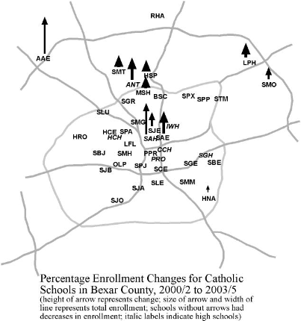
Figure 4.

Figure 5.
0.91^{b}
- 4.32^{b}
- 3.41^{b}
17.5
36.3
+ 1.9
Total Population
- 0.62
- 4.03
- 4.65
58.0
143.6
38.1
Latin Foreign Born
0.68
- 3.48
- 2.80
2.0
12.7
- 20.8
Non-Hispanic Whites
2.57
- 1.43
+ 1.14
48.1
70.6
- 2.3
Asians
2.12
- 7.96
- 5.84
18.1
68.2
- 13.6
Blacks
- 0.15
- 4.38
- 4.53
28.5
80.6
10.8
Hispanics

Growth of Ethnic and Immigrant Groups and Change in Dissimilarity Index (D):
Inner vs. Outer Cityª, San Antonio (Bexar County), 1990-2000

% Growth Rate, 1990-2000 Total Change Components of Change
Group of group in the: in D Index, in Dissimilarity Index:
Inner Cityª Outer Cityª Entire City 1990-2000 Inner City Outer City
ª Inner City refers to Census tracts within Loop 410 (see Fig. 1); Outer City, to those outside Loop 410.
^{b} Average Dissimilarity Index Change for the five above groups.
Figure 6.

Figure 7.
Figure 8.

Figure 9.

Figure 10.

Figure 11.

Residential
Location

Demographic characteristics
of family income, education, ethnicity, and religiosity)
Send child to a Catholic school

Figure 11. Conceptual Relationship between residential location, demographic characteristics, and sending a child to a Catholic school: San Antonio Catholics with School Age Children

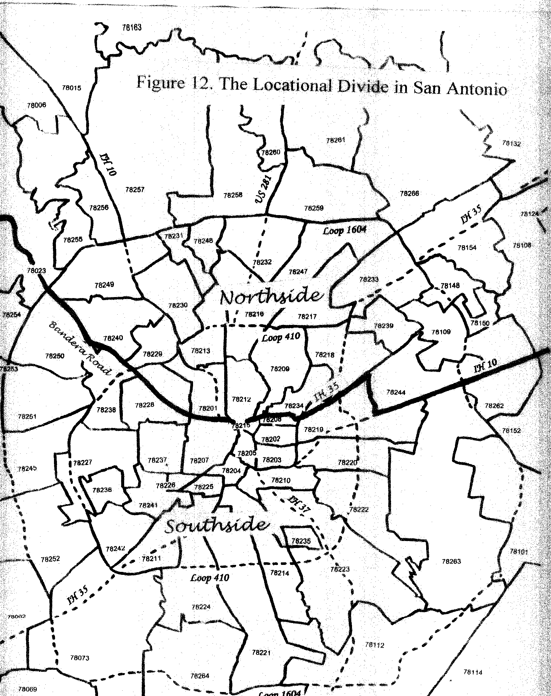

Figure 12
Figure 12 designates how researchers divided the city into north and south sides for purposes of analysis. Notice that the southside includes regions like the westside of San Antonio, for example.
Figure 13. Northside vs. Southside Residence in San Antonio in Relation to Attendance in a Catholic School and Selected Demographic Characteristics: San Antonio Catholic Families, 2005

Residence on:
Indicator: Northside Southside Overall

% with a child in Catholic elementary or secondary school | 26.2 | 15.8 | 21.1
% whose household income is $60,000 or more | 44.7 | 29.7 | 37.3
% where respondent’s education is college B.A. or higher | 51.5 | 36.6 | 44.1
% where spouse’s education is college B.A. or higher | 44.3 | 29.4 | 37.0
% of respondents of non-Hispanic ethnicity | 35.9 | 19.8 | 27.9
% of respondents who attend church at least once per week | 53.5 | 57.4 | 55.4
Number of cases | 103 | 101 | 204

Figure 14. Attendance in a Catholic School in Relation to Selected Demographic Characteristics: San Antonio Catholic Families, 2005 (n = 224)

% Attending Catholic School
for attributes of indicator:

Indicator: Yes No Overall

Is household income $60,000 or more? | 22.8 | 19.3 | 20.5
Is respondent’s education a college B.A. or higher? | 27.5 | 14.8 | 20.5
Is spouse’s education a college B.A. or higher? | 26.4 | 18.1 | 20.5
Is respondent of non-Hispanic ethnicity? | 25.8 | 18.6 | 20.6
Does respondent attend church at least once per week? | 26.7 | 10.8 | 19.8

Figure 15. Commute Time and Locational Convenience: San Antonio Families Sending Children to Catholic Schools, 2005

Residence on:
Indicator: Northside Southside Overall n

Average commute time (minutes) to school | 27.9 | 29.1 | 28.3 | 466
Average commute time to school: elementary only | 25.0 | 26.9 | 25.6 | 272
Convenience of location (1-10, 10= extraordinary impor.) | 6.50 | 6.80 | 6.60 | 452
Convenience of location: elementary only | 6.89 | 6.87 | 6.89 | 266
Buses should be provided (1-5, 5=strongly agree) | 3.50 | 3.67 | 3.56 | 459
Buses should be provided: elementary only | 3.39 | 3.62 | 3.46 | 269

Figure 16. Characteristics of Selected Catholic Elementary Schools in San Antonio
S C H O O L
Atone- Our St. St.
ment Lady St. St. Mar- Philip
Aca- Perpet. Gre- Thomas tin of
Characteristic demy Help gory More Hall Jesus
Classificationª | FN | FN | NN | NN | S | S
ARCHDIOCESE ENROLLMENT DATA:
Average enrollment, 2003-2005 | 342 | 436 | 622 | 200 | 296 | 237
Enrollment change, 2000/02 to 2003/05 (mov.av.) | +74.5 | + 9.5 | - 3.0 | - 3.9 | -13.8 | -14.9
MURDOCK (UTSA) DATA:
% Pop.change in analysis area of school, 1990-2000 | +73.0 | +21.0 | + 6.3 | + 5.6 | - 0.7 | - 8.3
Mean household income in analysis area 2000 ($) | 92771 | 60171 | 45561 | 61592 | 34200 | 32064
% college graduates 2000 | 51.0 | 32.7 | 18.4 | 39.2 | 8.5 | 10.9
SURVEY DATA: FAMILIES IN THE SCHOOL:
Mean family income ($) | 116400 | 71120 | 65900 | 73300 | 49500 | 62300
% with B.A. degree (respondent) | 60.0 | 56.0 | 52.2 | 73.0 | 54.5 | 61.5
% Hispanic (respondent) | 50.0 | 29.2 | 69.6 | 58.3 | 72.7 | 84.6
% attending church ≥ once per week (respondent) | 90.0 | 69.2 | 91.3 | 62.2 | 33.3 | 78.6
Average commute time to school, minutes | 34.2 | 21.9 | 34.0 | 25.3 | 22.7 | 25.2
% of children commuting from non-adjacent ZIPS | 43 | 25 | 51 | 66 | 65 | 89
N (number of sample Catholic children attending) | 15 | 41 | 37 | 57 | 17 | 20
N (number of sample Catholic families sending kids) | 10 | 25 | 23 | 37 | 11 | 13

ª FN = far northside, rapid enrollment growth; NN = near northside, slight enrollment decline; S = southside, pronounced enrollment decline.

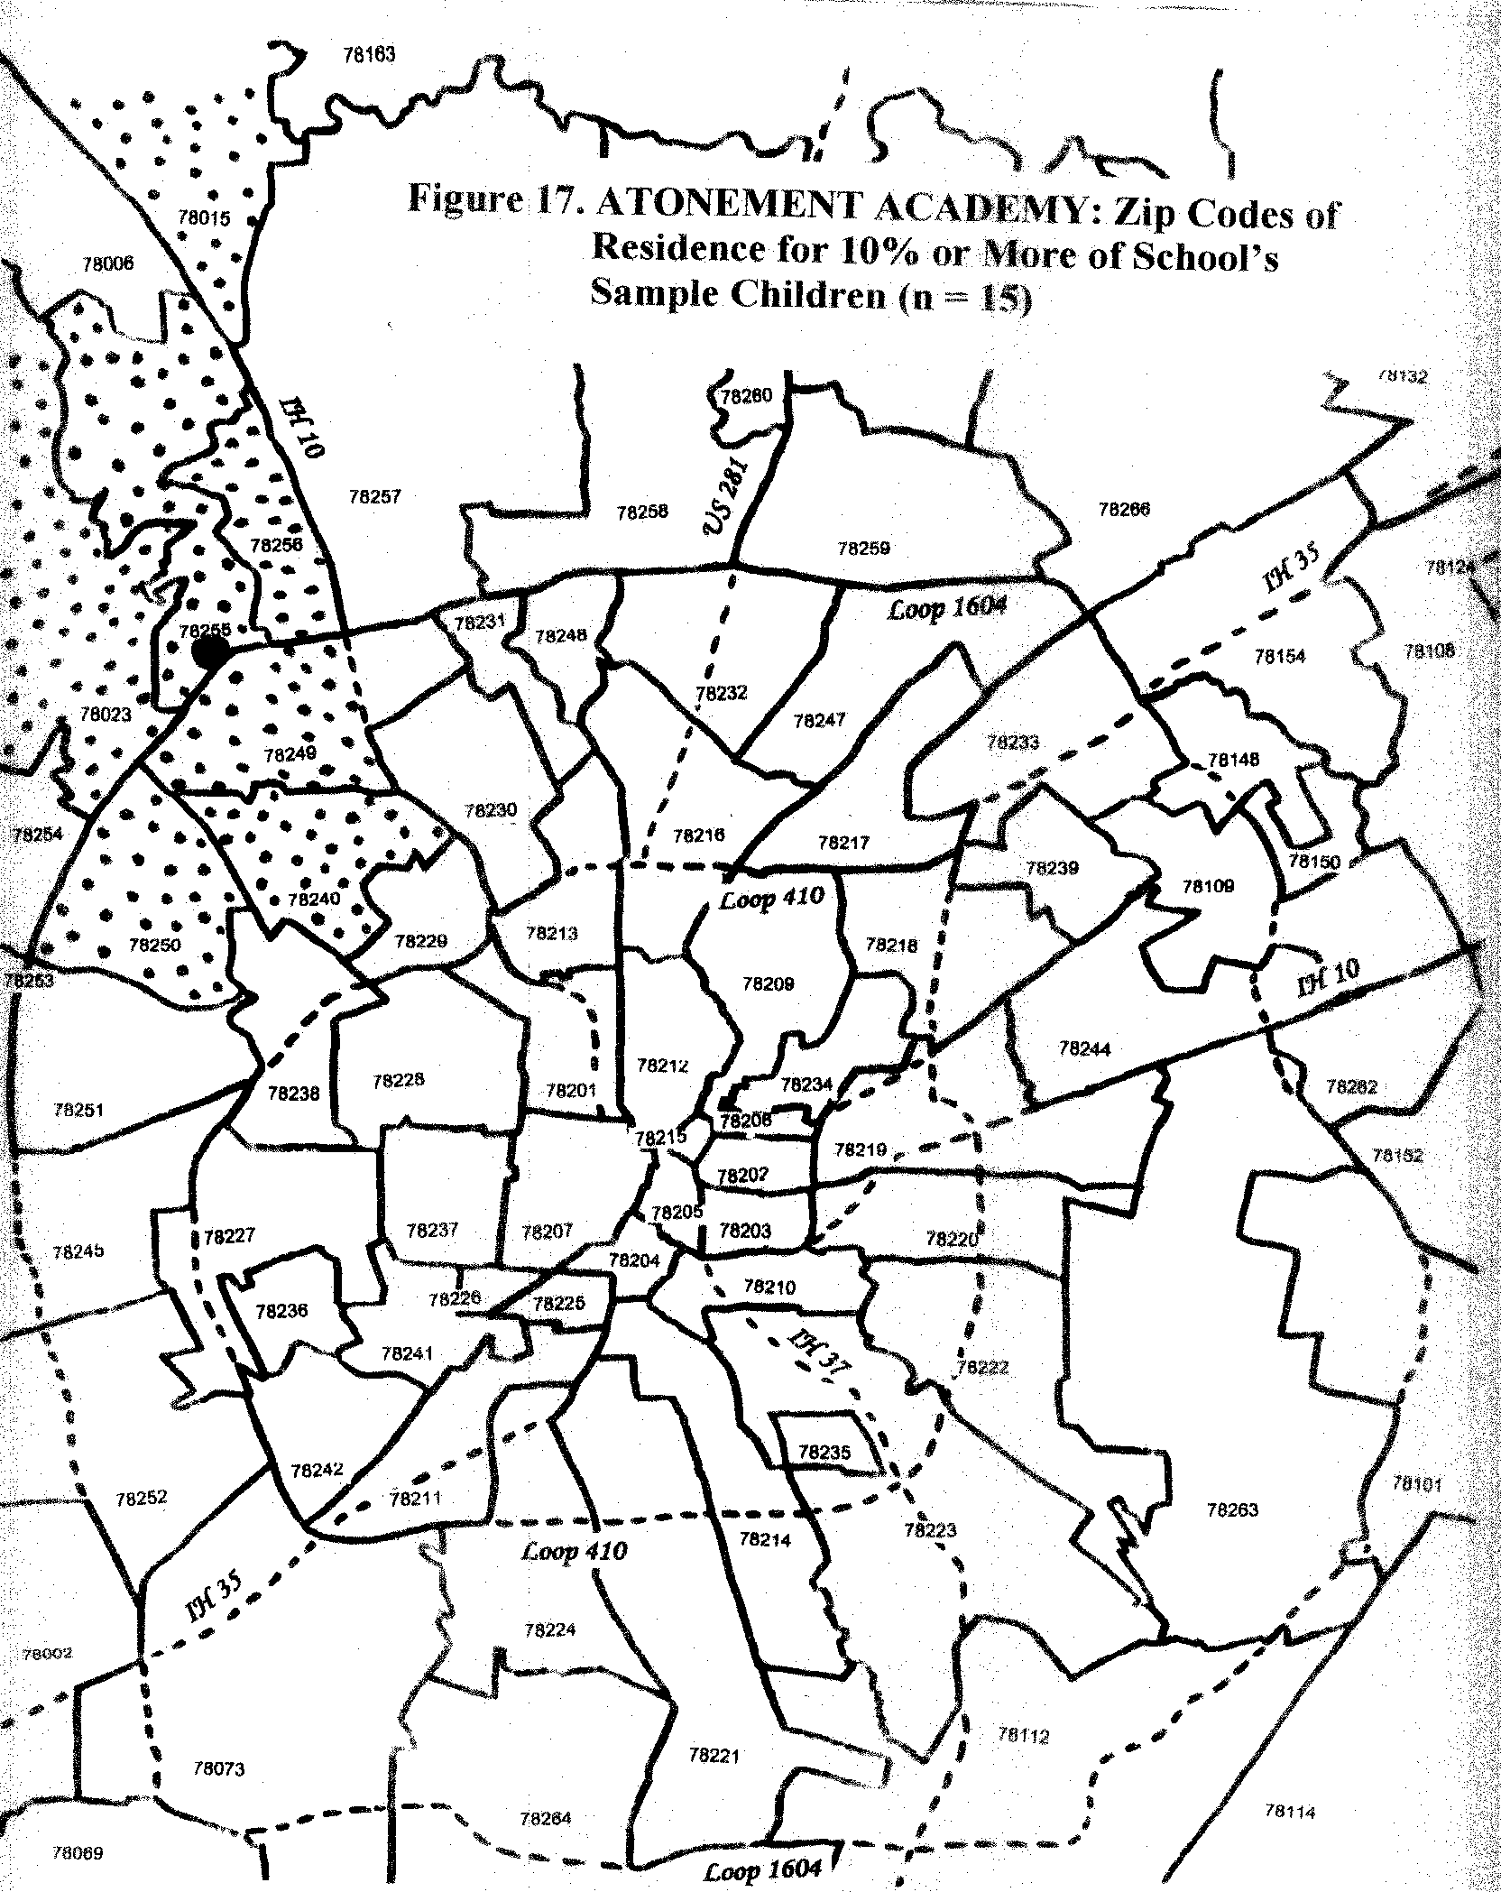
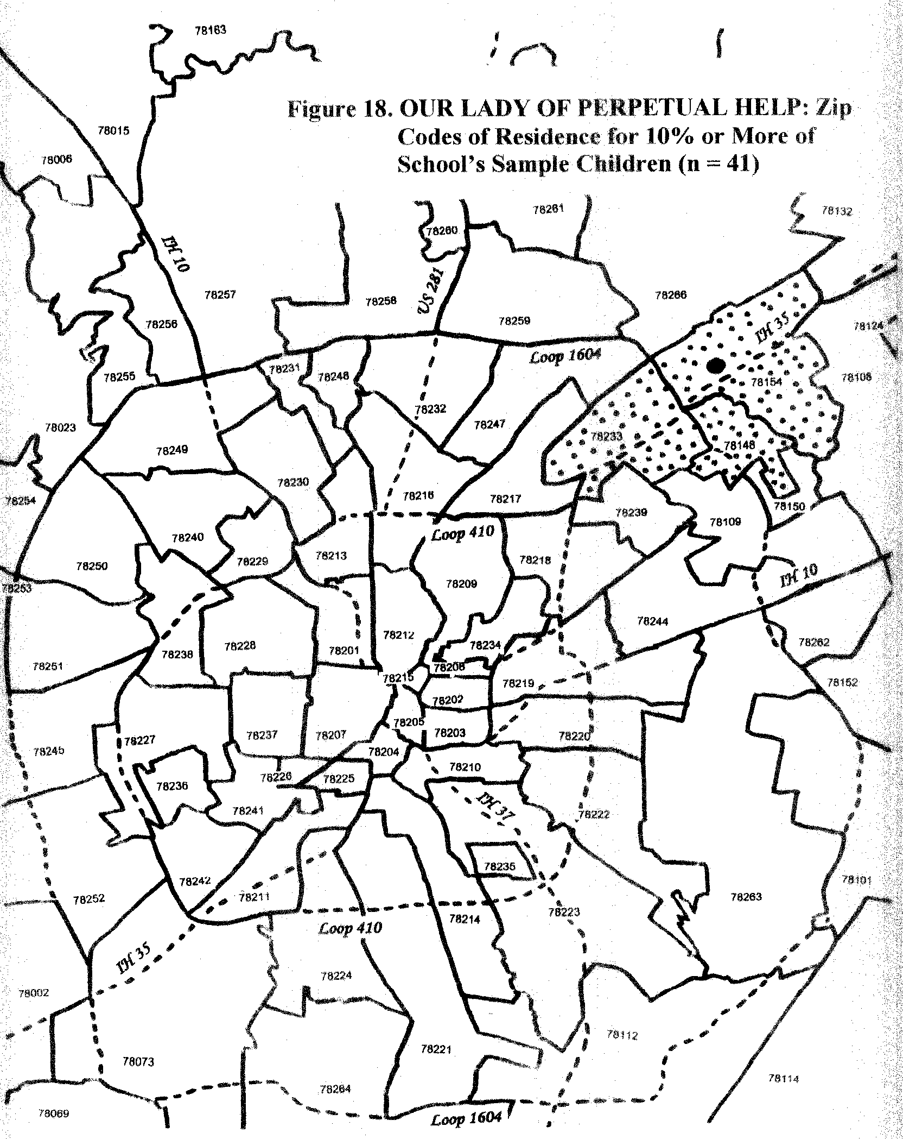
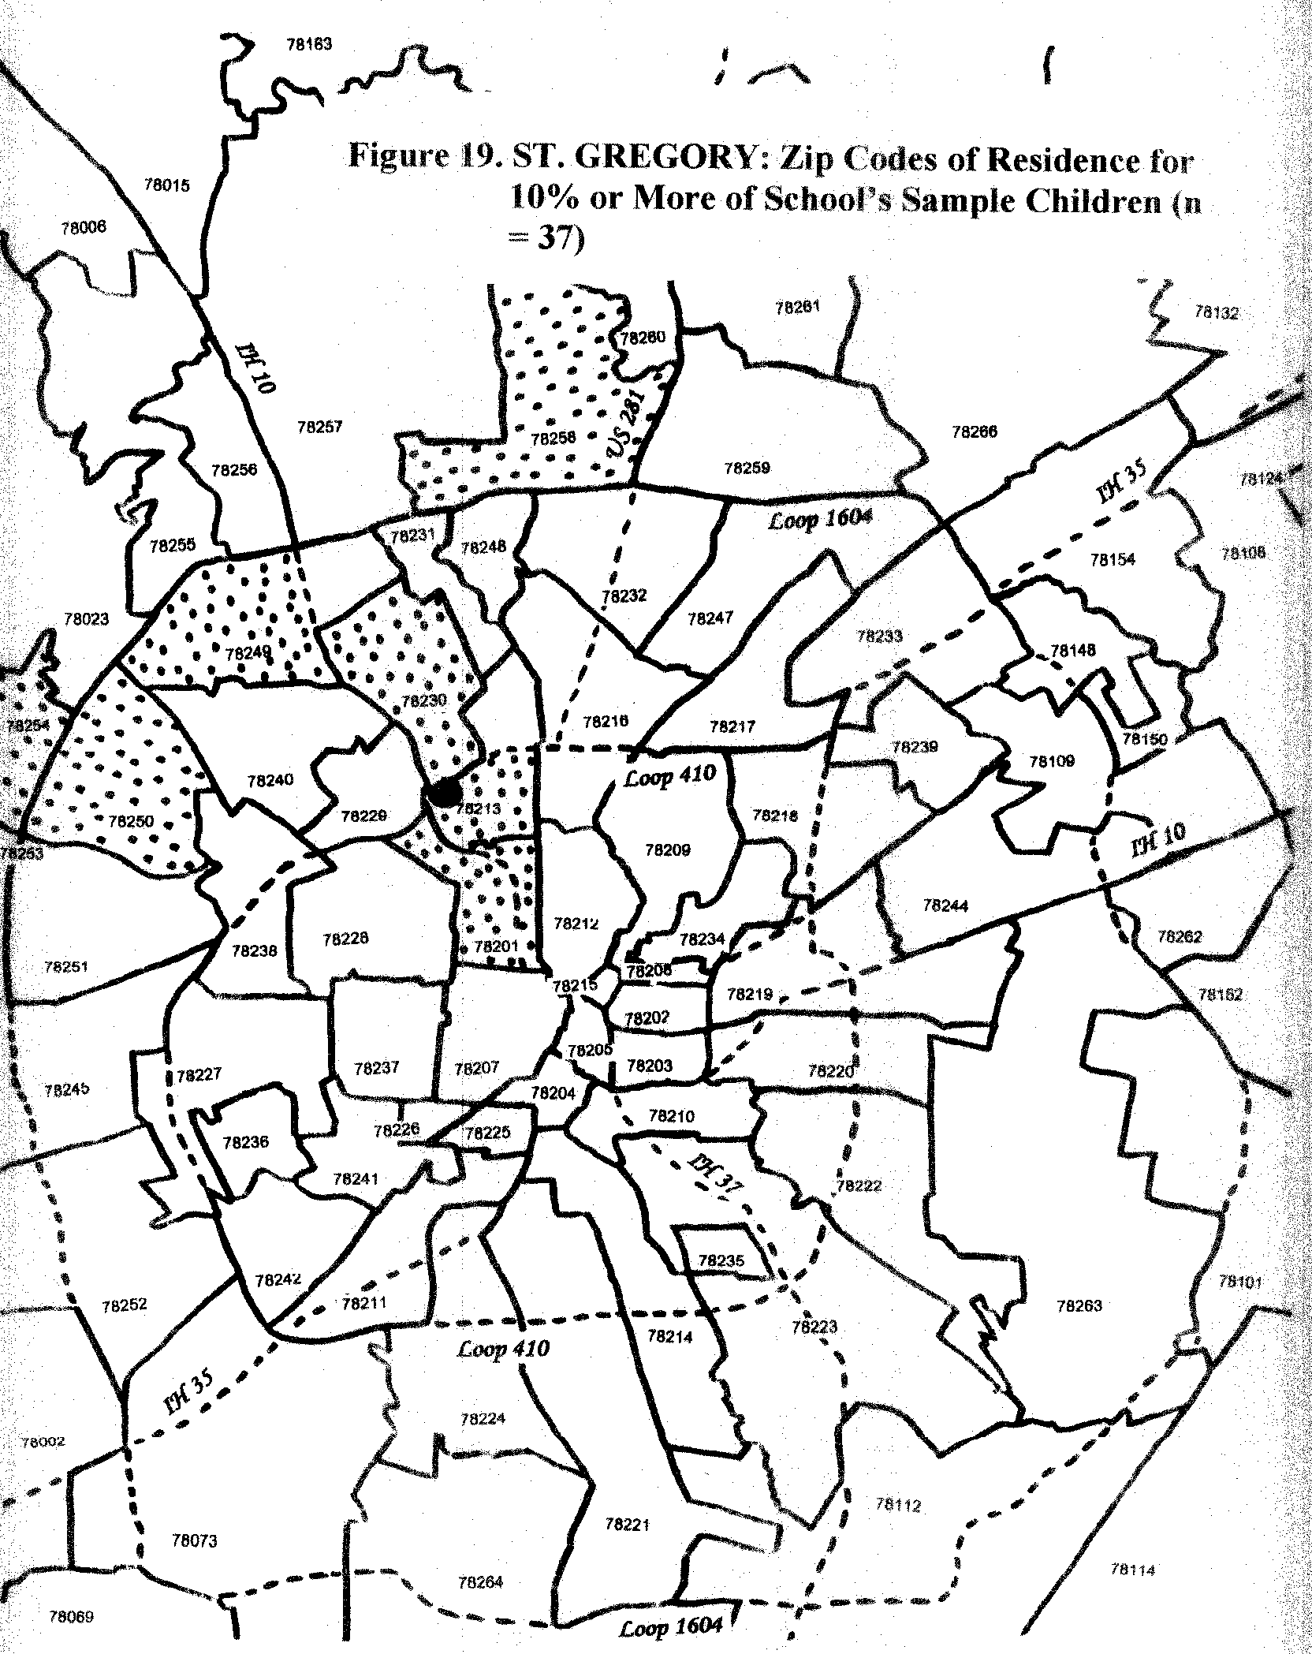
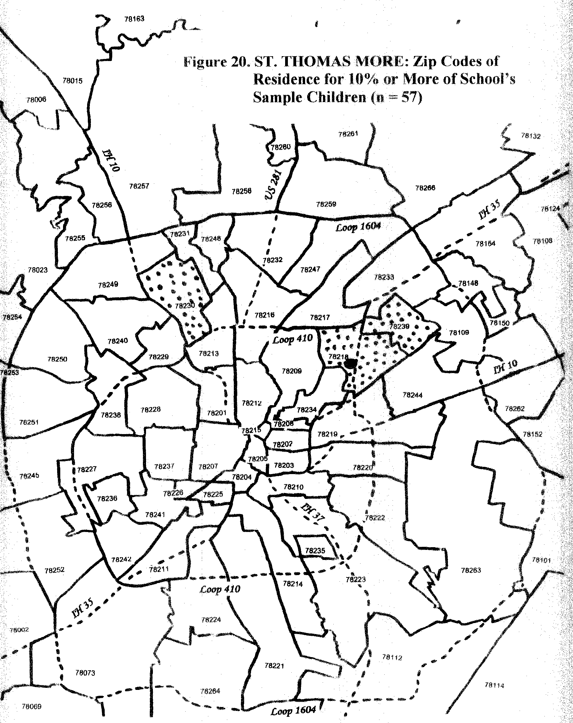
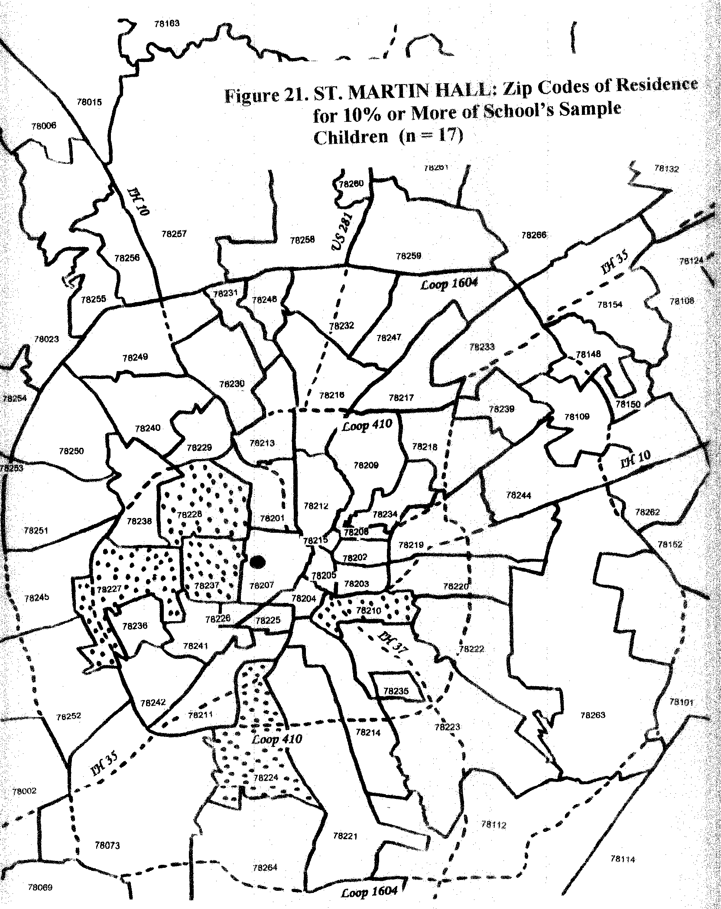
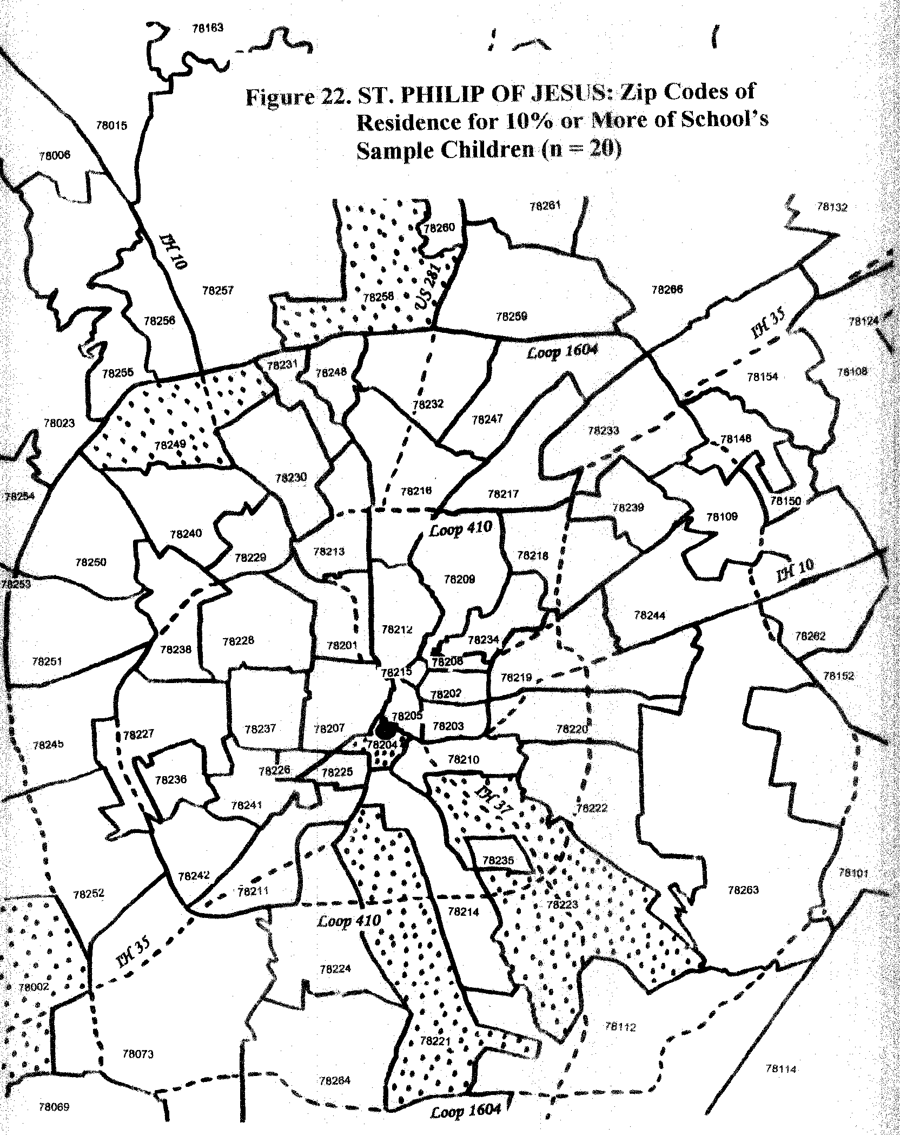
Figure 23. Northside vs. Southside Residence and Opinions on Quality of Catholic Education: San Antonio Catholic Families Sending Children to a Catholic Elementary School, 2005 (Average score: strongly agree = 5, strongly disagree = 1)

Residence on:
Indicator: Northside Southside Overall

Catholic schools give better acad. preparation than public | 4.25 | 4.23 | 4.25
My child’s school builds character | 4.79 | 4.71 | 4.77
My child’s school friends have a positive influence | 4.46 | 4.36 | 4.43
Catholic schools are essential to the church’s mission | 4.48 | 4.27 | 4.42
My children’s schools are safe | 4.72 | 4.70 | 4.71
My child’s school respects my ethnic background | 4.72 | 4.73 | 4.72
The church should keep quality poor schools open | 4.45 | 4.46 | 4.45
The Archdiocese should rejuvenate the poorest schools | 4.09 | 4.40 | 4.19
The Archdiocese should consolidate struggling schools | 3.38 | 3.37 | 3.38
The Archdiocese should open more Catholic schools | 3.28 | 3.34 | 3.29
I would contribute to scholarships for poor students | 3.91 | 4.05 | 3.95
Number of cases | 310 | 144 | 454

Declines have resulted from a variety of reasons including (1) demographic changes (e.g. Church schools remain in neighborhoods that have (a) grown very poor and population cannot pay the tuition, (b) declined in population of school-age children, (c) population emigrating to more suburban venues or (d) the decline of parishioners in older parishes with schools; (2) the increased cost of (a) maintaining the older schools, (b) of operating the schools because of salary increases especially those resulting from the sharp decline in nuns and brothers engaged in teaching, and (c) of new and costly technology demands; (3) the increase of competition from other religious denomination schools; and (4) the equalization of public school finance leading to greater revenues for and adequacy in public schools located in property-poor neighborhoods—among other reasons.
For instance, this past year school closings were announced in Brooklyn, Queens, Boston, Chicago, Philadelphia, Buffalo, and Cleveland, as well as San Antonio and other cities. On the other hand, since 1985, 204 elementary schools and 26 high schools have opened For a review of Catholic school openings and growth, see: National Catholic Education Association, John Augenstein, PhD, and Neal Meitler, “Catholic School Growth 1985-1999,” http://www.ncea.org/newinfo/catholicschooldata/csgrowth.asp and numerous other accounts and commentaries, e.g., Paul M. Wyrich, “Catholic Education: Reversing School Closing Policy,” June 8, 2005, Free Congress Foundation, http://www.freecongress.org/commentaries/2005/050608.asp. Locally, one can look most recently at Karen Adler, “Holy Rosary closing this spring” San Antonio Express News, 2/19/2006 at http://www.mysanantonio.com/news/education/stories/MYSA021906.06B.holy_rosary.2ea4013.html; and Karen Adler, St, Gerard fights as ranks dwindle,” San Antonio Express News, 2/13/2006, at http://www.mysanantonio.com/news/education/stories/MYSA021306.1A.gerard.876c6cb.html, which discusses the 2001 closing of St. Gerard’s elementary school and three others in the past decade, and the ongoing decline in enrollment in St. Gerard’s high school. Other articles on Catholic schools can be reviewed at http://www.mysanantonio.com/news/citycouncil/stories/MYSA013106.3B.catholicschools.cdbd9ee.html,
National Center for Education Statistics (NCES), October, 2005; National Assessment of Education Progress – The NAEP 2005 Mathematics Report Card; Scale Scores and Percentage of Students in Catholic and Public Schools at Various Achievement Levels—a few examples provided. Scale Scores Catholic Public Catholic Public Grade 4 Math 244 237 Grade 8 Math 290 278 Grade 4 Reading 234 217 Grade 8 Reading 280 260 Grade 12 results forthcoming in 2006, and for further explanation of data, see: http://nces.ed.gov/nationsreportcard/about/nonpublicschools.asp. The 2000 data indicated the superiority of scores of students of private schools over public schools. Of course, these issues are complex, especially when controlling for demographic variables such as parental education and income, as indicated by Section II of this report. For current data, see either above link to NCES or below to NCEA: http://www.ncea.org/newinfo/catholicschooldata/naep2005.asp
See Karen Adler, “3Private Schools get Blue Ribbons,” San Antonio Express-News, 9/5/2005 http://www.mysanantonio.com/news/education/stories/MYSA092305.05B.blue_ribbon.1ce8fdac.html
This refers to northside and southside schools as defined by this study, with northside constituted by a wedge from Bandera Road to Loop 410, the E-W segment of I 35 N, to IH 10 East, see Map located in Appendix A, Figure 12.
The fusion is the key, but some subtle and not significant differences are detected regarding greater weighting of either the religious or academic components, e.g. among “southside” and “northside: residents, respectively.
http://www.mysanantonio.com/news/education/stories/MYSA121505.01A.northside_growth.17df6319.html
Four studies included in Appendix B, the ULI Study Growth Scenario and Texas Perspectives Scenario A, B, and C provided by City of San Antonio, revised September 30, 2005.
The Pastoral continues: “For a century and a half the Church in the United States has been distinguished by its efforts to educate the poor and disadvantaged, many of whom are not of the Catholic faith. That tradition continues today in - among other places - Catholic schools, where so many blacks, Hispanics, Native Americans, and Asians receive a form of education and formation which constitutes a key to greater freedom and dignity. It would be tragic if today, in the face of acute need and even near despair, the Church, for centuries the teacher and the guardian of civilization, should withdraw from this work in our own society… See it in full text: http://www.osjspm.org/cst/racism.htm
See logistic regression models and probability analyses in Explanatory Working Paper # 3 for explanation of statistical methods.
Bishop Wuerl was selected as incoming Chair of the Board of Directors of the NCEA in December of 2005, taking office in April of 2006. See: http://www.ncea.org/newinfo/mediareleases/newsdetail.asp?release_id=157.
The University of Pittsburgh, School of Education, evaluation of the program stated: “This [school] environment, which combines an academically oriented program with one that is value-based, is highly regarded by both parents and students, making these schools a major and important resource for urban families.” See their Report Card on the four schools of the Mile High Program at: http://www.extramilefdn.org/eval.html.
Quoted in Wyrich, note 2.
The report appears at: http://www.archdiocese-chgo.org/pdf/genesis.pdf with explanatory news release at:http://schools.archdiocese-chgo.org/news_releases/news_2005/news_111405.shtm
Alan J. Borsuk and Sarah Carr, “Lessons from the voucher schools: How is Milwaukee's experiment to expand school choice for low-income students faring 15 years later?” Milwaukee Journal Sentinel Online, June 11, 2005
See Zelman v. Simmons-Harris 536 U.S. 639 (2002) http://caselaw.lp.findlaw.com/cgi-bin/getcase.pl?court=US&navby=case&vol=000&invol=00-1751 http://www.oyez.org/oyez/resource/case/1496/
As Chief Justice Rehnquist wrote in the 5-4 decision: “In sum, the Ohio program is entirely neutral with respect to religion. It provides benefits directly to a wide spectrum of individuals, defined only by financial need and residence in a particular school district. It permits such individuals to exercise genuine choice among options public and private, secular and religious. The program is therefore a program of true private choice. In keeping with an unbroken line of decisions rejecting challenges to similar programs, we hold that the program does not offend the Establishment Clause.”
V. Dion Haynes, “Vouchers Breathe New Life Into D.C. Catholic Schools: Tuition Rates, Morals Appeal to Parents” Washington Post, Monday, June 13, 2005, page A01, WashingtonPost.com: http://www.washingtonpost.com/wp-dyn/content/article/2005/06/12/AR2005061201241.html Graphic of impact of the voucher program appears at: http://www.washingtonpost.com/wp-dyn/content/graphic/2005/06/13/GR2005061300004.html
See William G. Howell and Paul Peterson, with Patrick J. Wolf and David E. Campbell, The Education Gap: Vouchers and Urban Schools, Brookings Institution, 2002; William Sander, Catholic Schools: Private and Social Effects, Kluwer Academic Publishers, 2000. See significant reviews of these two books by Kenneth Godwin and John Coons, two academic experts on education policy at: “Choice Words,” Hoover Institute, http://www.educationnext.org/20023/83.html.
Kansas City, Central City School Fund http://www.centralcityschoolfund.org/ with financial breakdown at: http://www.centralcityschoolfund.org/annualreport/Financials.pdf
See: http://www.ncpa.org/press/ceo422.html.
e.g. http://www.aspira.org/aollatino_aspira.htm AOL Latino or Aspira Oracle http://www.aspira.org/ or SBC and LULAC http://www.csrwire.com/article.cgi/2866.html, Microsoft and HACU http://www.microsoft.com/presspass/press/1999/Dec99/LatinoCommPr.mspx , etc.
Very favorable things were mentioned about University of Incarnate Word’s outreach and partnerships by several participants in the qualitative interviews before the survey research. Other than to UIW, feint praise, if any positive comment, was given to other universities in the region. This may be due, of course, to the sample of interviewees for in-depth interviews, which are always limited.
Sander’s and other books or empirical research such as William G. Howell and Paul Peterson, The Education Gap: Vouchers and Urban Schools, Brookings Institution, 2002, show a common finding, that private schools improve the educational outcomes of African-American children but not others in urban areas. Moreover, instruction at religious schools does raise the level of religiosity among students and that lasts into maturity affecting positively both amount of prayer and contributions to the church. These religiosity findings are consistent with findings from our Project.
. 72% were Hispanic, 23% Anglo, 1% African American, 1% Mixed, 3% Other.
The statements actually read to the respondents appear in Appendix C.
The three statements are the ones represented in the bar-chart list, following in “moral values” but not in the order shown by the means: “The academic quality of the Catholic school?” (58%); “Catholic schools put religious teachings into academic education?” (56%); and “The individual attention given to students in the Catholic school?” (51%)
Seventy-five percent of those who responded that tuition was a major impediment also said that they have considered sending their child to a Catholic school. This is a higher percentage than the general population.
For clarity, the analysis excludes parents who have children in both Catholic and Public schools. Here we concentrate only on families where one or all children attend either public or Catholic schools.
For description of logistic regression models employed in these analyses and for more full account of the methods and findings, see Supplemental Report, Demographic Factors, Religiosity, and School Choices: Executive Summary of Key Findings
Arguments might be developed from evaluation studies to attempt to convince state legislature that vouchers could (a) save tax dollars, (b) positively affect test scores for urban poor (demonstrably African Americans), (c) positively impact retention rates, and (d) enhance the rate of furthering ones education after high school—all of vital importance to Texas presently. Complex topic, highly controversial, but worthy of task force exploration at critical, pivotal time in Texas.

